Electrabel SES process

This document provides an explanation of the S(ervice) E(ntry) S(heet) process and gives instructions to help you fill out the SES template (.xls) correctly.
If you use the procedure outlined below, you can be sure of:
- fast invoicing and payment;
- correct monitoring of the services rendered and costs incurred (budget of your PO).

You will always need to request an SES number before you can draw up an invoice for a service order*. You can do so using a general Excel file that you can obtain from the BUG-PI-SES Department (BUG-PI-SES@engie.com ).
After you have filled in all the data, you can send the template to BUG-PI-SES. If you have a worksheet signed by an Electrabel manager, you can send it too.
The template will be processed and an SES number will be issued for it. After it has been approved electronically by the technical or budget manager, you will be sent the SES number by e-mail, along with your stated reference number.
Both the SES number and the PO number (order number) must be included on the invoice.
Please send your invoice according to the instructions stated in the purchase order

* This procedure is only required for service orders within BUG. If you are not sure whether it applies, you can always check your purchase order.

SES PROCEDURE

1 Supplier
After the services have been provided, send an SES request to the BUG PI SES Department by e-mail: BUG-PI-SES@engie.com. The SES template and the worksheet (if there is one) should be attached to the message.

The BUG-PI-SES Department processes SES requests within 24 hours. This period may expire if there is not enough budget left on your order. If this happens, action will be taken with the technical and purchasing departments in-house to resolve the problem.
2 SES Team
(BUG-PI-SES)

The technical/budget manager checks the SES numbers that have been created and endorses them electronically. You will be informed if the manager does not approve the numbers.

3 Technical manager

The BUG-PI-SES Department sends the approved SES numbers to the supplier.
4 SES Team
(BUG-PI-SES)

The supplier’s invoicing department creates the invoice, taking care to mention the SES number and the PO number. The invoice is then sent according to the instructions stated in the purchase order.
POSTBUS 33
2600 BERCHEM

5 Supplier

Conditions for invoicing for services provided
- The supplier must have an order (either for a fixed amount of for controlled expenditure).
- Every SES template must be marked with a unique reference number (the communication number). If this number is not unique, the SIVF numbers cannot be generated.
- E-mails to the BUG-PI-SES Department must meet a number of conditions:
- The subject of the SES request must be structured as follows:
SUPPLIER NAME_ORDER NO _UNIQUE REFERENCE NO
- The name of the scanned and electronic worksheets must be structured as follows (optional):
SUPPLIER NAME_ORDER NO _UNIQUE REFERENCE NO

Guide to the Electrabel SES template

OPENING THE ELECTRABEL SES TEMPLATE
The SES template must be saved somewhere other than your inbox.
If you want to fill out an SES request, please always select it from the location in which it is saved on your computer.

STRUCTURE OF THE SES TEMPLATE
The SES template is made up of the following parts:
- The header, which contains general information;
- And the body, which contains detailed information about the services rendered.

= Header
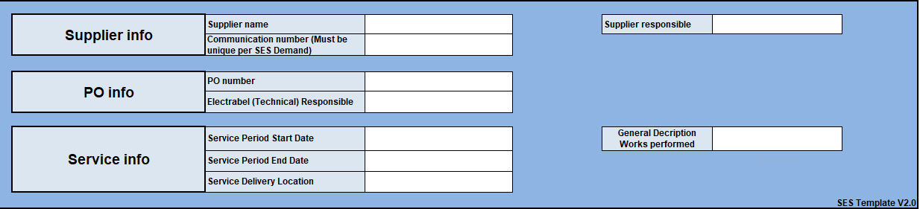
= Body
Filling out the Electrabel SES template
1
Filling in data for the header
- The data that need to be inserted in the header apply to all services covered by the SES template.
- For instance, given that the PO number is at header level, only services relating to that same order may be added to the Electrabel SES template (one SES template per PO number).

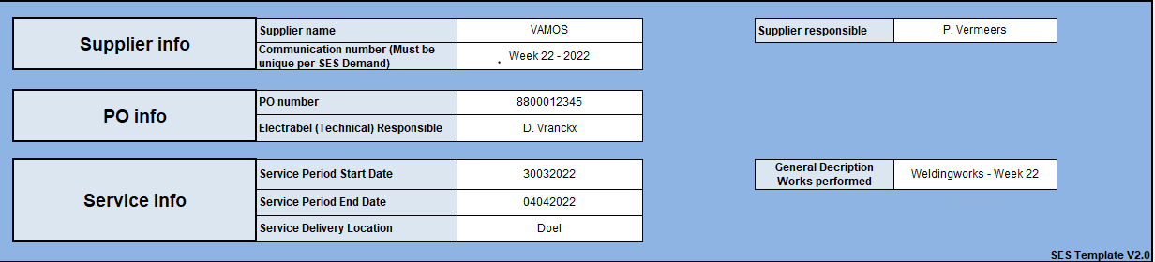
More info on the fields to be filled out:
Fields to fill out | Description | Format
Supplier name | = supplier’s name | Max. 30 characters
Communication number (must be unique per SES request) | = supplier’s unique reference number (selected by supplier) for each Electrabel SES template (e.g. invoice number) | Max. 20 characters (no special characters like / \ : * ? " < > |)  Only -
Order number (PO) | = PO (purchase order) number | 10 characters
Order number (PO) | •PO numbers starting with 88 are framework orders | 88XXXXXXXX
Order number (PO) | •PO numbers starting with 99 are spot POs  You cannot get an SES number without a PO number! | 99XXXXXXXX
Electrabel (Technical) Responsible | =supplier manager for the services rendered | Surname + First name – Max. 12 characters
Service period start and end dates | = start and end dates of the service provision period to which the Electrabel worksheet relates | DDMMYYYY  End date > start date
Service delivery location | = name of the Electrabel site where the services were provided | Max. 16 characters
Supplier responsible | = name of the supplier’s contact person (in connection with SES requests) | Max 12 characters

Tip: Every Electrabel SES template must bear a unique supplier reference number (communication number) determined by the supplier.
- SES numbers cannot be generated if this number is not unique.
- The BUG-PI-SES team communicates the generated SES numbers on the basis of this number.

Filling in the body of the Electrabel SES template
2
- The data to be included in the body of the Electrabel SES template are the actual services provided to Electrabel by the supplier for the order and invoicing period mentioned in the heading of the Electrabel template.
The basic rule of thumb for filling out the Electrabel template is that every different type of service or hourly rate must be placed on a separate row.
Below is a step-by-step description of how to complete each service row (required fields).

1
Fill in the worksheet number

- You need to insert the worksheet number in the first cell. If you do not have one, leave the cell blank.
2
Fill in the PO item number
- You can find this number on your PO and/or worksheet.
The PO item number is always a multiple of 10 (e.g. 10, 20, 30).

3
Fill in the service description (max. 40 characters), number of units used, unit of measure and hourly rate
- Service description:
- Hourly rates for people: first name/surname (full name) + role + additional information about the sort of hours (e.g. normal working hours/overtime/weekend work/shift)
- Fixed-rate work: description of the job (possibly with payment rate + price fixed)
- Material supplied: description of material
- # services/items per unit of measure:
- This is where you should insert the number of hours worked, amount of material used or number of kilometres travelled
- Unit of measure:
- This is where you should insert the unit of measure used for the services, materials or journeys (see the (Unit of measure) tab to help you select the right units of measure)
- Price/unit:
- This is where you insert the price per unit of measure (excluding VAT)
Tip:
- The light-blue Subtotal column is filled in automatically for each row.
(e.g.: 40 hrs x €50 = €2,000)

Fill in the PM order number
4

- Your Electrabel manager will have given you the PM or internal order number. If you have not been given this number, please leave the cell blank.
If the order number starts with a 2, please insert it in the column Internal order number. If it does not, insert it in the column PM order number.
- Filled in automatically
- Please always insert “F” here
- You can insert extra information or details about the services provided here (max. 120 characters)

SENDING THE ELECTRABEL SES TEMPLATE

To save your completed SES template, press F12 (Save As ) then save the document, keeping to the following file name structure:
SUPPLIER NAME_ORDER NO_UNIQUE REFERENCE NO.XLS

Send the saved, completed SES template and the scanned worksheet (if you have one) to the following e-mail address:

BUG-PI-SES@engie.com

This e-mail address is also your point of contact for any questions about the status of your SES request or how to fill in the SES template correctly.
BUG-PI-SES can also be contacted by telephone on +32 2 501 13 29.

Annex: units of measure
Here is an overview of Electrabel’s recognised abbreviations for units of measure. You can find the most frequently-used abbreviations in the shortlist below.
All possible abbreviations have been stored in the detailed list (see the Units of Measure tab of the SES template).

