HSEP (Health, Safety & Environmental Plan) standard form
RENSEIGNEMENTS GéNéRAUX
Contracting company
!! Doc 1a to be attached !!
Address
Tel/Mobile
VAT no
Project manager + tel./mobile
Health and safety advisor tel./mobile
Accident statistics
(last five years)
Frequency rate
Severity rate

GENERAL INFORMATION SUBCONTRACTOR 1
Subcontractor company 1
!! doc 1b to be attached !!
Adress
Tel/Mobile
VAT no
Project manager + tel./mobile
Health and safety advisor tel./mobile
Accident statistics
(last five years)
Frequency rate
Severity rate

GENERAL INFORMATION SUBCONTRACTOR 2
Subcontractor company 2
!! doc 1b to be attached !!
Adress
Tel/Mobile
VAT no
Project manager + tel./mobile
Health and safety advisor tel./mobile
Accident statistics
(last five years)
Frequency rate
Severity rate

!! Warning !! Temporary staff and students are not permitted, except with a written exemption from Electrabel's management !!

Project order number ……………………………
Site  (delete unnecessary mentions ) | TGV Saint-Ghislain / TGV Amercoeur / Turbo-jet Deux-Acren/Coo
Electrabel project manager
Purpose
Method  (Describe in a few words the working method) | …………………………………………………………………………………………..  …………………………………………………………………………………………..  …………………………………………………………………………………………..  …………………………………………………………………………………………..  …………………………………………………………………………………………..  …………………………………………………………………………………………..  …………………………………………………………………………………………..  …………………………………………………………………………………………..  …………………………………………………………………………………………..  …………………………………………………………………………………………..  …………………………………………………………………………………………..  …………………………………………………………………………………………..  …………………………………………………………………………………………..  …………………………………………………………………………………………..  …………………………………………………………………………………………..
List of Workers
Names | Job

!! Copies of clearances and diplomas must be attached do not forget to attach the Limosa where relevant !!
!! Do not forget the authorizations to work on machine tools (drill press, workshop saw, grinding drum ...) !!
Internal Declaration of Competence

I Undersigned ………………………………….…………………………………., …………………………………. …………………………………. (position) of the company ………………………………….…………………………………. registered office in …………………………………., at…………………………………. ………………………………….………………………………….…………… (Address), certify that the following persons are authorized:

MS …………………………………., or Mr. ………………………………….,
Use a safety harness (Remove competency if not required)
Work at heights (Remove competency if not required)
Use scaffolding (Remove competency if not required)
BA4 / BA5 (Remove competency if not required)
Operate fork-lift trucks, cherry pickers, manitou, bridge (Remove competency if not required)
Rigger (Remove competency if not required)

MS …………………………………., or Mr. ………………………………….,
Use a safety harness (Remove competency if not required)
Work at heights (Remove competency if not required)
Use scaffolding (Remove competency if not required)
BA4 / BA5 (Remove competency if not required)
Operate fork-lift trucks, cherry pickers, manitou, bridge (Remove competency if not required)
Rigger (Remove competency if not required)

MS …………………………………., or Mr. ………………………………….,
Use a safety harness (Remove competency if not required)
Work at heights (Remove competency if not required)
Use scaffolding (Remove competency if not required)
BA4 / BA5 (Remove competency if not required)
Operate fork-lift trucks, cherry pickers, manitou, bridge (Remove competency if not required)
Rigger (Remove competency if not required)

MS …………………………………., or Mr. ………………………………….,
Use a safety harness (Remove competency if not required)
Work at heights (Remove competency if not required)
Use scaffolding (Remove competency if not required)
BA4 / BA5 (Remove competency if not required)
Operate fork-lift trucks, cherry pickers, manitou, bridge (Remove competency if not required)
Rigger (Remove competency if not required)

He/she/They has/have been made aware of the operation of the equipment to be used, the safety instructions, the precautions to be taken, the protective equipment to be used and the dangers that the use could pose to himself/herself, to third parties, to the environment or to the material damage that it may cause.

Declared on honor as sincere and true.,

Done at ……………….., on ../../…. Signature :

List of hazardous products
Names | Use

!! The safety data sheets must be attached !!

List of equipment subject to statutory inspections
Equipment | Use

!! The inspection certificates must be attached !!
Environmental risks
Risks | Measures to be implemented

Health and safety risks
Risks | Mesures qui seront mises en œuvre | Residual risks

If your company has conducted risk assessments, it is better to attach them to this SHEP rather than filling in the risk assessment and environmental analysis tables.
Do not forget to attach docs 1a, 1b, (acknowledgement of general safety regulations for contractors), Limosa, copies of SCC and ISO certificates, etc.
The documents of the general and specific Engie Electrabel conditions and the general HSE regulations contractors for ENGIE Electrabel Production are included with the order

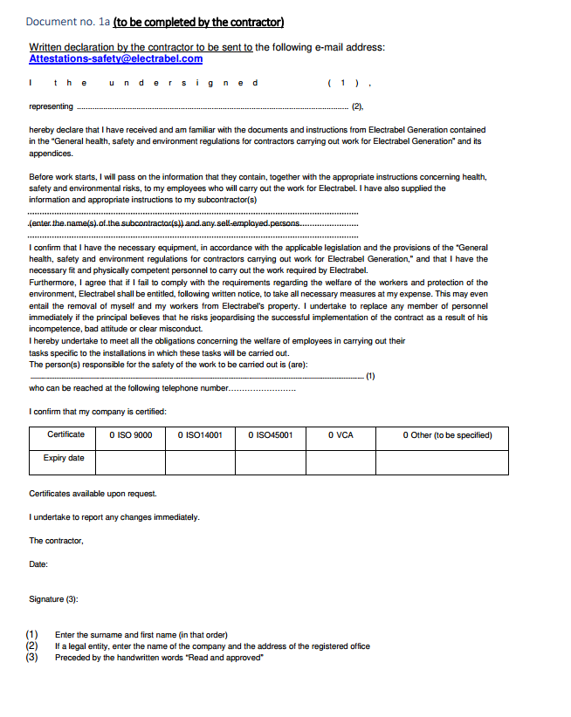

DOC 1B
