Dear,

We can offer you a new functionality by sending your invoices via mail instead off paper (PDF format).

In order to accept your request in sending your PDF invoices via mail you have to fulfill following conditions:

* **1 invoice represents 1 PDF document (attachment included).**
* **The invoice must be conform to the invoicing rules as stipulated in the VAT regulation.**
* **Once you send via mail it is not allowed to send paper invoices.**

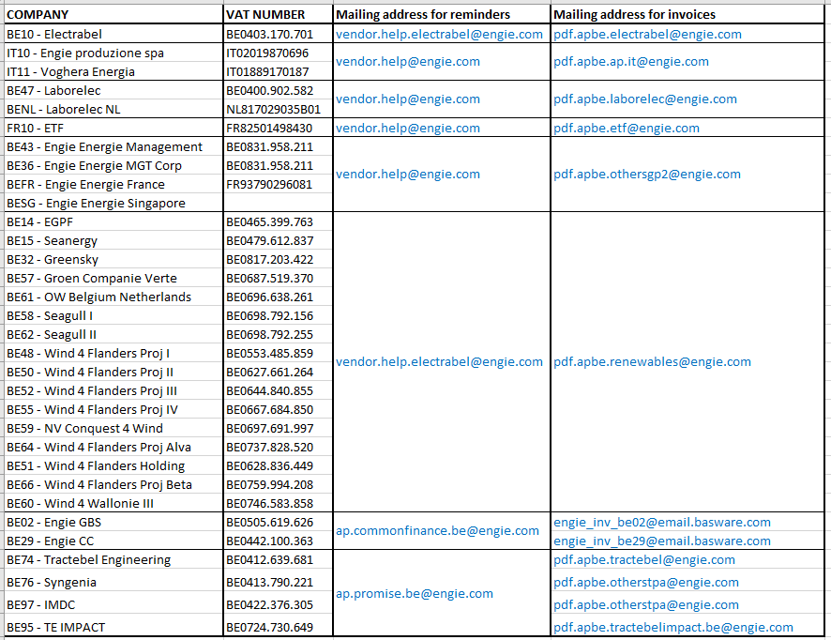

When these requirements are met your invoice will be treated accordingly. If not the invoice will be rejected which can lead to overdue payments.

Sincerely,

Accounts Payable - Finance Service Line