
APPENDIX – HEALTH & SAFETY

1. HEALTH & SAFETY COMMITMENT 2
2. HEALTH & SAFETY FRAMEWORK 3
2.1 CONTRACTOR’s HEALTH & SAFETY MANAGEMENT PLAN 3
2.2 H&S PLAN CHAPTERS 3
2.3 RISK MANAGEMENT PRINCIPLES 5
2.4 NO LIFE AT RISK PROGRAM AND 5 SAFETY ESSENTIALS 7
2.5 ENGINEERING, SYSTEMS, EQUIPMENT AND MATERIAL 9
2.6 SITE MANAGEMENT 10
2.7 PERSONNEL MANAGEMENT 11
2.8 SITE RITUALS 17
2.9 REPORTING & FEEDBACK 18
3. IMPLEMENTATION AND COMPLIANCE 20
3.1 RIGHT OF INSPECTION AND AUDITS 20
3.2 CONTRACTOR’S FAILURE TO COMPLY 20
3.3 NO VARIATIONS 21
EXHIBIT 1 – PERMIT TO WORK 22
EXHIBIT 2 – LAST MINUTE RISK ASSESSMENT - LMRA 31
EXHIBIT 3 – “STOP THE WORK” POLICY 32
EXHIBIT 4 – KEY PERFORMANCE INDICATORS 33

- HEALTH & SAFETY COMMITMENT
Health & Safety of the Project is the first priority in all activities the Owner and the Contractor plan and all actions the Owner and the Contractor take.
The Contractor is responsible for planning, managing and safeguarding the health & safety of people on Site.
The Contractor agrees and is committed to the Target Zero associated to Health and Safety. For the purpose of this Agreement, “Target Zero” means Zero accidents and Zero injury to achieve a world-class Health and Safety performance.
To achieve this, the Contractor must set-up a Project Health & Safety Management Plan including the requirements laid out in this document and obtain Owner’s agreement before mobilization.
The Health & Safety documentation and obligations applicable to the project flows from the “Target Zero” commitment down to the Project specific documentation and its implementation, in the following priority order:

For clarity, if the contract doesn’t refer to Owner and Contractor, for the purpose of this Appendix:
- Owner refers to the Client, Employer or other name given to the entity developing the Project and identified as such in the contract.
- Contractor refers to the entity performing the services and works and having an activity on Site (e.g., installation, construction, commissioning, maintenance, operation). This document is hence applicable to any supplier, contractor, sub-contractor, O&M operator or other, for their own scope.
- HEALTH & SAFETY FRAMEWORK
  - CONTRACTOR’s HEALTH & SAFETY MANAGEMENT PLAN
The Contractor must develop a detailed Health & Safety Management Plan for the Project to achieve the Health & Safety Commitment as described in 1 HEALTH & SAFETY COMMITMENT (in this document the plan will be referred to as “H&S plan”).
The Contractor must develop and implement a H&S plan as follows:
- The H&S plan must include at least the minimum requirements laid down in this Appendix. These minimum requirements are mandatory and will apply whether they are expressly integrated in the Contractor’s Health & Safety Management plan or not.

- The H&S plan must be adapted to the specific project implementation and must detail, develop, complete or add any requirement necessary to safeguard the health & safety of the people on Site.

- If there is an overarching project health & safety plan provided by the Owner, the H&S plan must comply with this overarching Project Health & Safety Plan. The same will apply in case there is another party designated by the Owner to coordinate the health & safety on site. In this case, the Contractor’s H&S plan must comply with this party’s project health & safety plan.

- The Contractor must also ensure that the H&S plan will comply with all the Applicable Laws. If the Applicable Laws require different or more stringent measures and actions than the applicable H&S plan, the Contractor will inform the Owner and will adapt the H&S plan to comply with the Applicable Laws.

- The Contractor will inform the Owner if there is a conflict or gap between different documentation. The Contractor will always follow the most protective or stringent measures.

- The Contractor must communicate and ensure that obligations are cascaded to every sub-contractor, consultant, supplier or other person appointed or coordinated by the Contractor or his sub-contractors, so they all comply and implement these requirements and the H&S plan.

- The Contractor acknowledges that timely identification and management of risk is viewed as a key element to preventing incidents. The Contractor must review and update the H&S plan at every change in the Contractor’s scope of works or in the Applicable Laws, working environment, conditions or organization.

  - H&S PLAN CHAPTERS
The H&S plan developed by the Contractor must cover at least the documents and content listed in the table below.
It must be shared with the Owner prior to mobilization on site. The Owner reserves the right to refuse commencement or to stop the works if the H&S plan has not been agreed.
1 | GENERAL MANAGEMENT PROGRAM | Prior to mobilization on Site.  Prior to mobilization on Site. | - Project brief description (title, location and site map, scope of work))  - H & S applicable legal requirements and standards  - H & S Organizational chart and responsibilities incl. line of command  - Staffing program  - Subcontractors’ management  - Co-activity and interface management  - Competence and certifications  - Communication (signs, safety talks, meetings, …)  - Rituals plan (see Section 2.8)  - Inductions & Training program  - Positive behavior program to promote Health & Safety culture on Site  - “No Life at Risk” ENGIE program (see Section 2.D)  - Change management  - Accident/Incident reporting & investigations process
2 | RISK ASSESSMENT & MITIGATION MEASURES |  | - See Section 2.3 (1) for details.
3 | SAFETY PROCEDURES |  | - Safety inspection (equipment and activity) procedures and check list,  - Joint safety tours and visits as per Section 2.8  - Safety meeting and committees,  - Tracking and resolving Safety issues
4 | SITE TRAFFIC PLAN |  | - Traffic plan (map with roads, access points, ...)  - Internal circulation for pedestrians, cars and engines  - Drivers training & management  - Speed limit control
5 | HAZARDOUS MATERIAL MANAGEMENT |  | - Storage & Identification of hazardous material  - Material Safety Data Sheets, including procedures for storage, use, maintenance and reaction to accidents.
6 | SUPERVISION & ASSURANCE ACTIVITIES |  | - Procedures for: day to day monitoring of activities and risks including work inspections and Works testing.
7 | SITE ARRANGEMENTS |  | - Base camp & on-site welfare facilities  - Site Housekeeping & sanitation  - First-aid and medical facilities  - Infectious diseases prevention and control  - Off-site / On-site arrangements
8 | SITE SECURITY |  | - Site security organization and resources  - Access control & monitoring  - Communication with local authorities
9 | EMERGENCY RESPONSE PLAN & CRISIS MANAGEMENT PROCEDURE |  | - Notification procedure,  - Evacuation procedures,  - Assembly point and headcount check,  - On-Site and off-Site medical treatment organization,  - Communication with emergency response personnel  - Evacuation / Emergency training & drills
  - RISK MANAGEMENT PRINCIPLES
The Contractor must ensure that all necessary Health & Safety assessments have been made at all times, and as appropriate for each activity. Health & Safety assessment will consider the scope of the Contractor as well of the interfaces.
The Works can only start when:
- The Health & Safety risk assessment has been performed by the Contractor.
- The H&S Plan has been shared with the Owner and there is no objection raised from the Owner.
- All the required safety conditions are met on site.
For the commissioning, the Contractor must obtain prior authorization of the Owner before starting the associated works and activities. The Owner can also request other activities to be subject to his prior approval before start and must communicate them in advance to the Contractor.
During the Works, all employees of the Owner, the Contractor or his sub-contractors, must call a STOP WORK if required by the situation, for their own safety and/or that of other people or property.
1 | RISK ASSESSMENT & MITIGATION MEASURES | As part of the H&S Plan | - Identification of Hazard, with at least:  - Electrical equipment & tools / Temporary Installations  - Live Electrical equipment  - Confined Space  - Rigging / lifting of equipment / machinery  - Work at height / Roof Work  - Scaffolding  - Manual handling  - Excavations  - Pressurized Systems  - Objects under induced stress  - Working Alone  - Hot work  - Explosives  - Commissioning  - Dangerous Substances  - Carcinogenic (CMR) substances  - Occupational diseases and contagious diseases  - Natural environment / Fauna / Flora  - Traffic on site / Roads transportation to and from Site  - Ergonomics  - Psychological risks  - Security  - Probability and severity rating (before and after risks mitigation)  - Risk criticality ranking  - Include mitigation measures for each risk  - Demonstrate that after implementation of mitigations measures, risks are As Low As Reasonably Practicable (ALARP).  - The deliverables are:  - Health & Safety Risk Register and/or  - Job Safety Analysis (potential hazards for a specific job and the safest way to perform it.
2 | SAFETY BY DESIGN | During the design and procurement activities | All engineering, systems, materials and equipment procured or used by the Contractor must follow the Safety by Design principle as detailed in Section 2.5.
3 | MANAGEMENT OF SAFETY CRITICAL ELEMENTS (SCE) | Along the project | Definition, Identification and management of Safety Critical Elements (SCE) as defined in Section 2.5.
4 | INSPECTION OF HAZARDOUS EQUIPMENT | Before use and periodically | Hazardous equipment identified in the H&S Plan (e.g., cranes, derricks, scaffolds, elevators and elevating platforms, …) must be inspected & certified by a qualified person before use and periodically as per applicable procedures and regulations.  Any detected deficiency must be recorded and corrected before use.
5 | METHOD STATEMENT / WORKING PROCEDURE | Before activity in preparation phase | Documents detailing exactly how to perform the work safely and controlling the risks identified in the risk assessment. It includes:  - Organization and Project details and contacts  - Description of activity;  - Requirements for resources needed & involved;  - Equipment required;  - Warning signs and Control measures;  - Details of emergency procedure;  - Collective protective equipment required;  - Personal protective equipment (PPE) required;  - Jobs Steps – description of how to safely perform works, step by step (pictures if required), with analysis of hazards, identification of controls and responsible.
6 | PERMIT TO WORK (PTW) | Before commencement of identified works | Formal Procedure to ensure that risks are identified, assessed and mitigated before, during, and after performing dangerous works.  It applies to electrical works, lifting works, pressurized systems, confined space co-activity and other works for which the PTW was identified as one of the mitigation measures in the risk assessment.  The Permit To Work process and principles are presented in EXHIBIT 1 – PERMIT TO WORK
7 | LAST MINUTE RISK ASSESSMENT (LMRA) | Before the commencement of Works | The workers must verify the risks on Site and that the minimum safety conditions are met to start the Works, as required by risk assessment and method statement.  The LMRA process and principles are presented on EXHIBIT 2 – “LAST MINUTE RISK ASSESSMENT” POLICY
8 | SPECIFIC RISK ASSESSMENT BEFORE COMMISSIONING | Before commissioning and testing | Specific risks assessment to include H&S review in commissioning readiness process:  - Risks and respective roles for testing before commissioning, in agreement with the Owner;  - Emergency procedures and prevention measures (e.g., fire suppression/prevention, Lockout/Tagout procedures, Permit to Work, which will have to be tested before the start of the activity.  - Training and awareness process for the Contractor’s staff as well as operating staff participating in the commissioning activities
9 | FINAL SAFETY REVIEW | As part of the Provisional Acceptance Process | A final and formal safety review must be performed by the Project Management team involving the H&S Expert before the official project handover to the Owner. This will include checking, controlling and solving any H&S issue resulting from test of critical systems and functions.

  - NO LIFE AT RISK PROGRAM AND 5 SAFETY ESSENTIALS
The Contractor confirms that he is duly informed on the content of the Owner’s program “No Life At Risk” to prevent serious and fatal accidents, and its 5 mandatory rituals called “safety essentials”, and will include them in his H&S Plan.
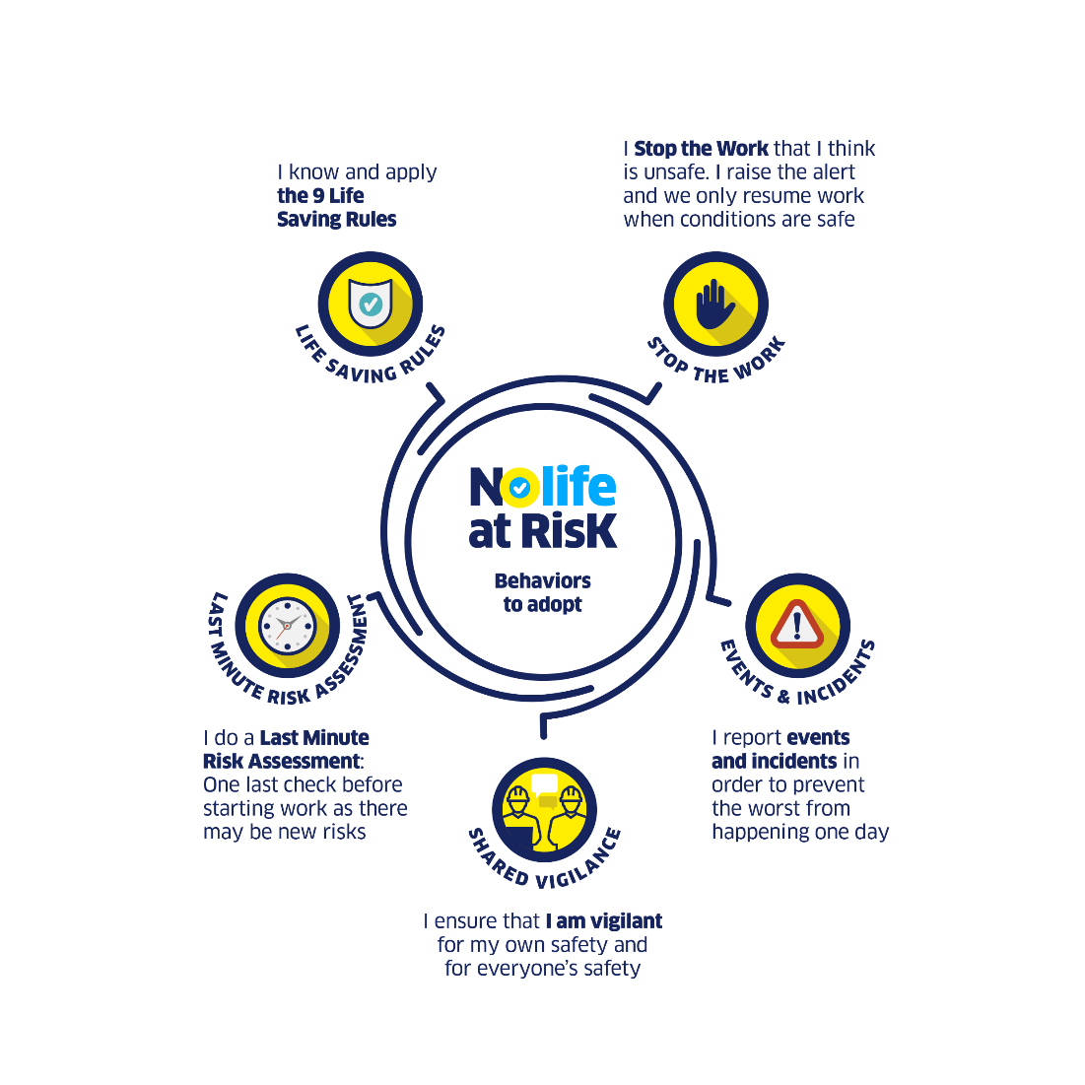
The Contractor must communicate and ensure that all Sub-Contractor’s and people working on Site are equally informed & aware of the NO LIFE AT RISK “safety essentials”. The communication will be done through the induction program, the regular toolbox meeting, flyers on site, booklet for induction, reminders by supervisors/foremen/managers during daily activity as well as any other appropriate means.

    - LIFE SAVING RULES (“LSR")
Life Saving rules are the fundamental rules to be respected by the Owner, the Contractor and its Sub-contractors in order to save lives. If they are respected, lifesaving rules will allow to avoid most of accidents. Every person on Site must be aware of them and follow them.

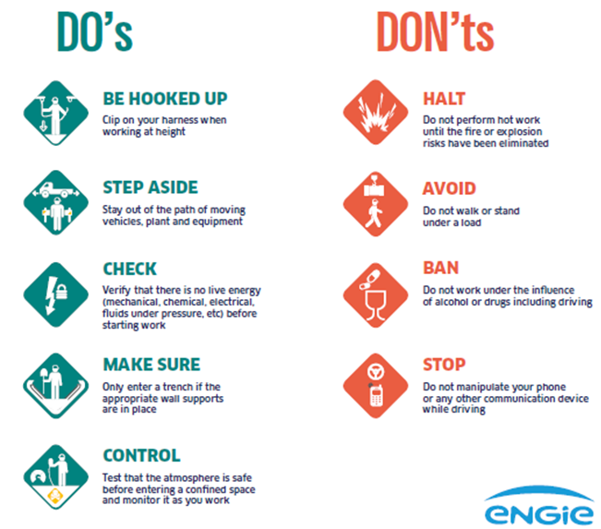

    - Events & incidents (HIPOs)
A High Potential Incident (HiPo) is defined as an event that resulted:
(a) resulted in a near miss or in an incident with consequences; and
(b) that could have led to a ​life-altering serious injury or fatality.​

The Contractor must immediately report HiPos must be immediately reported to HSE Manager. The Contractor must perform a deep root cause analysis, carried by his operational line and health and safety support. The root cause analysis will also include an appropriate action plan and communication plan to mitigate future risks.

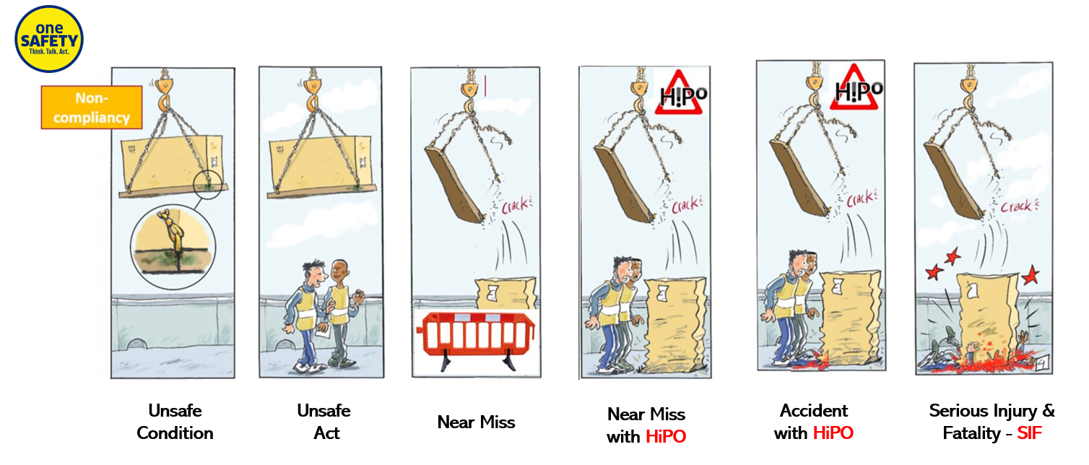
    - “Stop the work”
Stop Work Authority means that if you feel a situation or an activity is not as safe as it can be, you have the duty and power to stop it immediately. It is each person’s duty to help to ensure safety for the people working and visiting the Site. In the event of serious and imminent danger, Contractor’s and subcontractor’s Personnel and any individual working on Site shall:
  - cease Works immediately, for the own safety of all people on Site.
  - alert the supervisor in charge of activity and site H&S manager immediately, so that the risks are re-analyzed and the conditions for restart are defined.
  - only resume the task when safety conditions are restored, and authorization is given by the HSE manager.
Stop The Work principles are presented on EXHIBIT 3 – “STOP THE WORK” POLICY
    - SHARED VIGILANCE
Shared vigilance means general duty of being vigilant for your own and for everyone’s safety. All persons on Site must:
- alert immediately the site HSE Manager and/or supervisor in charge of activity if their safety seems threatened,
- accept and properly react to someone who intervenes to protect their own safety and wellbeing.
    - LAST MINUTE RISK ASSESSMENT (LMRA)
The LMRA (Last Minute Risk Assessment) or “Life Saving Minute” consists in making a check on field by identifying the risks and talking the necessary mitigation actions, as close as possible to the actual working place, just before starting any activity. The principles and the way to carry out this verification are presented in EXHIBIT 2 – LAST MINUTE RISK ASSESSMENT - LMRA.
  - ENGINEERING, SYSTEMS, EQUIPMENT AND MATERIAL
The Contractor will develop its design, procure, and use only engineering, systems, Equipment and Materials integrating Safety by Design concept.
This means incorporating safety considerations into the design of materials and equipment, systems, or processes from the outset. The goal of Safety by Design is to eliminate or reduce hazards and risks to the lowest possible level, rather than attempting to address them after the fact through measures such as warning labels, personal protective equipment, or administrative controls.
This will include any measure and functionality with the aim of minimize risks for users during construction and operation, such as isolation and Lock Out and Tag Out (LOTO), interlock, ergonomic features, collective protection instead of individual and management of Safety Critical Elements (SCE) as described below.
- SCEs refer to any barrier that has the purpose of preventing or limiting the effect of a major accident and the failure of which could cause or substantially contribute to a major accident.
- Barriers can be any system equipment, device, engineering or other administrative control of a temporary or permanent facility or its plant.
- A major accident is a source of danger that has the potential to cause death, serious injury, permanent disability, significant damage to the plant, equipment or environment (e.g., fires, explosions, electrical chock, load drop, fall from height or releases of dangerous substances).
As part of the risk management principles, the Contractor must:
- Identify the SCE
- Integrate the SCE as part of the H&S Plan
- Define and implement specific inspection and maintenance plan, with fixed frequency and tests or reviews
- Define and implement quality assurance (QA) requirement for SCE
- Define and verify competences required for use of SCE
- Document and report the result of the Tests as per Section 2.9 Reporting and Feedback.
  - SITE MANAGEMENT
    - PERMITS
The Contractor needs to obtain, renew and maintain all the permits, approvals, Permits to Work (see EXHIBIT 1 – PERMIT TO WORK ), permissions needed to authorize works and ensure the security of the persons on Site.
    - SITE ACCESS RESTRICTIONS
The Contractor must limit the site access to authorized persons: employees of the Contractor, of his Sub-Contractor or persons authorized by the Owner.
The Contractor must request prior Owner’s authorization before authorizing access to site to persons not speaking the local language or English.
The Contractor is responsible for keeping unauthorized persons off the Site.
The Contractor must ensure that there is an appropriate level of H&S induction/training for any person entering the Site, being workers, or visitors (see Section 2.7.3 INDUCTION & MENTORING PROCESS)
The Contractor shall at all times take all reasonable precautions to prevent any unlawful, riotous or disorderly conduct by or among the personnel, and to preserve peace and protection of persons and property.

PROHIBITED ACCESS
PRESENCE OF FIREARMS
(Security staff may be authorized under certain conditions)
PRESENCE OF PERSON UNDER THE INFLUENCE OF PRESCRIBED MEDICINES
May be authorized if certified fit to work by the Doctor nominated in the H&S Management Plan
PRESENCE OF PERSON UNDER INFLUENCE OR POSSESSION OF INTOXICANTS AND NARCOTICS
UNPROFESSIONAL CONDUCT: FIGHTING, GAMBLING, COCK FIGHTS, HORSEPLAY, ETC.
Unprofessional conduct includes all behaviors which can affect the physical or mental health and safety of people working on site (e.g., Bullying)

    - SITE HOUSEKEEPING
The Contractor must ensure that the fundamentals of site management housekeeping are enforced at all times during its works.
The Contractor must in particular:
- Provide any permanent or temporary work, including roadways, footways, flagmen, warning signs, guards and fences which may be necessary for the accommodation and protection of owners and occupiers of adjacent land, the public and others;
- Provide lighting, fencing, guarding, watching and security of the Works;
- Keep the Site and Works clean and tidy and clear of unnecessary obstruction, including remove waste regularly and remove all Contractor’s Equipment that is no longer required for the performance of the Works;
- Provide protection and warnings for all overhead utility lines, underground pipes, conduit or cables;
- Regular cleanup of facilities;
- Keep hazardous material and waste in adequate containers;
- Provide dedicated adequate hazardous material and waste storage area to isolate construction wastes containing oil or other pollutant substances and avoid spillage.
- Take necessary measures for the prevention of fires on the Site;
- Take necessary measures for the elimination of excessive dust or smoke resulting from the Works;
- Take necessary measures for protection of adjacent properties from negative impacts of the Works, such as collapse, discharge, and from dust, smoke, fire and chemical or other intrusion.
    - COLLECTIVE PROTECTIVE EQUIPMENT
The Contractor will ensure that the appropriate Collective Protective Equipment (CPE) is available and used on Site. These CPE are any device or system of a collective scope, intended to preserve the physical integrity and health of workers, as well as that of third parties. It includes for example guardrail, scaffolding or cherry picker instead of rope access.
CPEs should always be considered as the first step of risk mitigation (after risk elimination), because they protect many, but also because they don't usually require action by the individuals using them.
  - PERSONNEL MANAGEMENT
    - PEOPLE WORKING ON SITE
The Contractor must ensure that appropriate personnel is appointed to work on Site, either directly by him or through his sub-contractors.
The Contractor must then ensure that all people working on Site are appropriately qualified, skilled and experienced in their respective trades or occupations.
The Contractor must maintain CVs, training history and certifications for all personnel and provide such information to the Owner on request.
The table below show the minimum roles and responsibilities to be appointed by the Contractor.
MANAGERS & SUPERVISORY PERSONNEL |  |  |  | HEALTH & SAFETY MANAGER
Appointed as needed for the compliant and safe execution of the Works. | Must speak local language and English. |  |  | To be appointed as part of Key Personnel before the start of the Works. | Must speak the local language and English.
- Lead by example  - Ensure direct reports are competent for their scope and appropriately delegate  - Ensure all activities are suitably planned and resourced, with relevant CPE & PPE.  - Participate to the deployment of the H&S plan, through the communication of risks and operating procedures, the facilitation of H&S talks and the promotion of positive behaviors.  - Make regular H&S checks via inspection, site walkdowns, joint site tours.  - Report near misses, HiPos, accidents and participate in the analysis of the root causes and action plans.  - Apply the “STOP WORK AUTHORITY” practice if necessary |  |  |  | - Encourage and influence right behaviours  - Evaluates identified risks and mitigation measures  - Develops H&S plan  - Identifies and coordinates interfaces for the project  - Ensures H&S plan implementation  - Ensures that individuals receive appropriate training before mobilization  - Ensure the proper conduct of regular H&S talks, and provide support to supervisors/managers  - Investigates incidents and provide required investigation reports.  - Make regular H&S checks via inspections, audits, and joint visits.
ALL PERSONNEL |  |  |  | HEALTH & SAFETY SUPERVISORS
Appointed as needed for the compliant and safe execution of the Works. | Must understand the local language or English. |  |  | Minimum 1 supervisor per 50 direct workers at all phases of the project. (Min. of 1 also applies if there are less than 50 direct workers on the project Site).
- Accept responsibility for their own health and safety in the workplace  - Ensure that they are fit for duty  - Utilize and maintain the relevant PPE  - Know the relevant emergency preparedness and response procedures  - Follows sound work practice techniques and Health & Safety rules  - Stop Work if required |  |  |  | - Supervises work activities from Health & Safety perspective  - Ensures that individuals receive appropriate training before mobilization  - Ensures regular H&S talks are held by supervisors and participates in them  - Evaluates the identified risks as well as the mitigation & control measures  - Make regular H&S checks via inspections, audits
 |  |  |  | OTHER H&S ROLES
 |  |  |  | Coordinators or other roles can be hired as required by law or foreseen in the H&S plan.
    - SUB-CONTRACTING LIMITATIONS
Sub-contracting is limited to 1 level of sub-contracting. Any further level of sub-contracting (i.e., sub-contractors of sub-contractors) must be authorised by the Owner.
Regardless of the level, the Contractor must obtain prior written consent of the Owner if he intends to sub-contract any of these activities:
- the management of all or part of the Site activities;
- the Health and Safety management and supervision of construction activities;
- services including the safety, security and reliability during the operation of the Plant.
The Contractor will ensure that his agreements with all sub-contractors (and their own sub-contractors, if any) include the same minimum requirements and allow for inspections and audits of all activities on site and Health & Safety related obligations.
All the above obligations prevail on any contradicting clause in the Agreement.
    - INDUCTION & MENTORING PROCESS
The Contractor must ensure all his employees go through the ENGIE mandatory “One Safety” Induction, which covers the No Life At Risk “Safety Essentials”.
The Contractor must also ensure that all people working on Site, whether employed by him or indirectly through Sub-Contractors will follow an induction process so that they are individually fully aware of the applicable rules, operating mode, and their duties, depending on the nature of the work.
A separate (basic) induction training for site visitors must be developed and implemented.
Induction and trainings must be delivered in the language appropriate to the workforce.
The induction must include a test or other mean to ensure the knowledge comprehension and access to the site may be restricted as required.
The Owner must validate the induction material (H&S Booklet…) before its implementation. This materiel must include the “No Life At Risk” program.
The Contractor must keep a record of all inductions and trainings and make them available to the Owner.
Whenever a major change in the construction site is identified, the training is updated and performed again.
INDUCTION PROCESS
APPLICABLE RULES |  | DUTIES TO COMPLY
- HSE responsibilities & expectations  - Working conditions at site  - Hazards and risks associated with the performance of the Work  - Local Health & Safety regulations  - Policies applicable at site  - "No Life at Risk” safety essentials  - Introductions, housekeeping, designated smoking areas etc.  - Site Orientation  - Safety signs and restricted access areas  - Alcohol and Drugs Policy  - Personal & Collective Protective Equipment (PPE & CPE)  - Environment & Water Management Strategy  - Emergency Response, Evacuation Plans, muster points and Alarms  - Operating procedures & work instructions for the planned activity |  | - Comply with applicable rules at all times.  - Bring to the immediate attention of the supervisor all Health & Safety risks which they believe not to be under adequate control, so that actions are taken to:  - prevent potential injuries, health, safety or environmental incidents and other losses  - provide a healthy and safe workplace  - Carry out their own Health & Safety obligations, including strict duty to report "Near Miss" events, unsafe working conditions, hazards, dangerous incidents, accidents and release of any contaminant.

The Contractor must also implement a system to ensure that any newcomer or person who does not have the full capability to perform a specific work is part of a mentoring process.
As part of this mentoring process the Contractor must ensure that the following principles are applied.
MENTORING PROCESS
SUPERVISOR DUTIES |  | NEWCOMER IDENTIFICATION
- The works supervisor must be fully aware of the job training process to the newcomer  - He assigns tasks according to the degree of knowledge of the new recruit and trains him in his new tasks and/or equipment  - He physically accompanies the new recruit in carrying out his tasks  - He gives him additional tasks gradually  - The works supervisor does not give full responsibility to the person until the person fully masters the tasks and risks of activity and fully fit for the work. |  | - During this process, personnel who is following this specific training must be clearly identified by means of different and specific color of hat and safety vest.
    - PERSONAL PROTECTIVE EQUIPMENT (PPE) ON SITE
The Contractor must provide all adequate Personal Protective Equipment, in good condition, to all persons working on or visiting the Site.
The list below is indicative of the minimum standards. Other equipment must be required depending on the risks identified in the H&S plan or in the specific job safety assessment (JSA).
MINIMUM PPE TO BE USED AND MAINTAINED ON SITE AT ALL TIMES
WEAR AT ALL TIMES |  | WEAR AS REQUIRED BY ACTIVITY
- Safety helmet with shin strap  - Safety shoes  - Fluorescent safety jacket  - Any other PPE depending on identified risks |  | - Gloves  - Ear protection  - Safety glasses  - UV protections for outdoor tasks: including protective clothing, hats, sunglasses and SPF30+ sunblock.  - Electrician's insulating/arc flash clothing  - Electrician helmet with face shield  - ATEX clothing  - Full body safety harness and lanyards  - Respiratory protective device  - Welding attire  - Any other PPE depending on identified risks

The Contractor must define a zoning for applicable PPE by displaying recognized safety pictograms.
The Contractor must ensure that personnel is suitably trained in the use and maintenance of any issued PPE. This training will generally be included as part of the relevant induction process but may be included as a toolbox topic or similar meeting. All provided PPE must regularly be reviewed and inspected.
The PPE will be replaced when:
- it reaches its expiry date,
- it is subject to wear and tear,
- it has been involved in specifically protecting an individual from a substance or impact (e.g., object striking hardhat, deployed/used fall arrestors).
All PPE returned for replacement, must be destroyed and or disposed of in a manner to prevent its inadvertent (re)use by other personnel or re-issue.
    - PROMOTION OF SAFE BEHAVIOR
The Contractor acknowledges that promoting a fair culture is a decisive factor for achieving the Target Zero.
The Contractor must include in the H&S plan a system that:
      - RECOGNIZES AND REWARDS VIRTUOUS BEHAVIOR
Positive behaviors which participate to the Health & Safety culture must be acknowledged & recognized in order to improve safety. Individuals who comply with the rules, detect dangerous situations or take initiative to improve safety shall be incentivized. The scheme of recognition can take different forms, from congratulations, public mentions, small gifts to individual or collective bonus.

      - IDENTIFIES MISTAKES AS A SOURCE FOR IMPROVEMENT
Identification and reporting of mistakes by all people on Site must be encouraged, to allow continuous improvements of work organization, procedures, competences, etc.

Mistakes must be addressed adequately, and if needed individual training will be given to individuals committing mistakes. Only mistakes that appear to be repeated and/or intentional after an in-depth analysis, are to be sanctioned.

No employee can be sanctioned because he activated his right to stop a work, as allowed under the No Life At Risk Program.

      - ANALYSES ROOT-CAUSES OF HEALTH & SAFETY DEVIATIONS
When a deviation or breach of a safety rule has been confirmed, the Contractor will systematically analyze the causes of deviations in order to allow a clarification of rules, a sanction or other relevant actions.

      - SANCTIONS PROPORTIONALLY TO THE RISK CREATED
The Contractor will set-up a sanction system which must be transparent, formalized and shared, in order to be accepted by all.
The sanction system must be proportionate to the severity of the deviation (e.g., a green/yellow/red card system). Each level of reward and sanction must be made clear, as well as its timeframe (e.g., expiration after X months) and related procedure (reporting, additional training, etc.).
The Contractor must develop a similar sanction system (matrix) considering the below example:
 | 1ST TIME | 2ND TIME | 3RD TIME
VIRTUOUS BEHAVIOUR | RECOGNITION SCHEME
NON-COMPLIANCE TO A RULE THAT PROVES UN-ADAPTED | No sanction: revision of the rule, working conditions or other adequate action
CARELESS BREACH OF A SAFETY RULE | Verbal notice, training or other support | Moderate disciplinary measure + training or other support | Severe disciplinary measure
BREACH OF A LIFE SAVING RULE | Moderate disciplinary measure + training or other support | Severe disciplinary measure
SABOTAGE OR INTENTIONAL BREACH | Severe disciplinary measure

The Owner can also request the recognition or sanction of a person under the safe behavior program.
    - REMOVAL OF PERSONNEL
The Contractor must apply a red card and remove any person employed on the Work Site, including Key Personnel, who:
- Is not appropriately qualified, skilled and experienced in their respective trade or occupation;
- Carries out duties incompetently or negligently in a manner which has or might reasonably be expected to have an adverse effect on the Works or on the Project;
- Intentionally or repetitively places themselves or others at risk of harm;
- Persists in any conduct or lack of care which is prejudicial to Health & Safety.
All above shall be agreed with its internal health and safety bodies including trade-unions.
The Owner can also request removal of any such person and the Contractor must remove this person.
    - OWNER’s HEALTH & SAFETY REPRESENTATIVES
The Owner has the right to monitor, control or otherwise supervise the Contractor’s compliance at all times. This includes the right to appoint Health & Safety representatives on Site, internally or through a third party, permanently or not.
The Owner’s representative can:
      - Encourage and influence the right behaviors;
      - Collaborate with the Contractor’s representatives through joint site tour, workshops, etc.;
      - Evaluate H&S plan development and implementation;
      - Request Health & Safety information and documents from the Contractor (including methods statements, certifications, etc.);
      - Report to Contractor and Owner when necessary;
      - Decide to delay or stop any work considered at risk without appropriate mitigation plan in place;
      - Issue green/yellow/red card (or any similar system implemented by the Contractor)
The Contractor must comply with instructions and decisions given by the Owner’s Health & Safety representatives.
  - SITE RITUALS
1 | TOOLBOX TALKS | ≥ 2/week during construction (as a minimum) | General Health & Safety talk by the foreman with the crews about the conditions at site, plan for the works to be performed, specific risks.  This is also the opportunity to share the experience from the unsafe situations and continuous improvement.
2 | PRE-JOB BRIEFING | Before specific tasks | Before the start of a specific activity, the site supervisor (different from the team operating manager) must brief the team on the specifics of the tasks:  - Details of work  - Associated Risks  - Method statements/working procedure  - Communication process  - PPE
3 | SITE WALKDOWNS | ≥ 1/day during construction | As part of their regular walk downs for work supervision, the Contractor must include regular Health & Safety observations and checks in addition to technical observations...
4 | JOINT SITE SAFETY TOUR | ≥ 1/week during construction  And before the joint safety committee meeting | The Joint Site Safety Tour is done by the Owner and the Contractor representatives, and its Sub-Contractors, to obtain a general appraisal of the working environment, H&S risk, measures, practices and to discuss safety matters et define potential added measure to implement.  The purpose must be focused on Health & Safety only.  It will include:  - routine inspections (verifying certificates and the state of equipment, engines, protective equipment, etc.);  - checks (assessing compliance with the Life-Saving Rules and safety instructions, the information given, the conformity of completed work, etc.);  - improvements and discussions with workers.
5 | JOINT SAFETY COMMITTEE MEETING | Monthly | Joint Safety Committee with the Owner and the Contractor representatives, dedicated to review and discuss the Health & Safety conditions on site, risks, and implementation of measure on site.
6 | AD HOC MEETINGS | As decided by the Owner or Contractor | The Owner or the Contractor can call for specific meetings at any time during the project, including risk assessment workshops or to review a specific method statement and related H&S risks.  These meetings may include joint managerial site visits, where the management of the Contractor and the Owner visit the Site together.  In the event of HiPO, accident, SIF (as specified in paragraph I) specific H&S meetings will be organized on site with managers and all of the contractor team to present and share the event, the causes and the action plan.
7 | AUDITS | Anytime | Some regular and scheduled H&S audits must be performed internally by the Contractor itself, or by the Owner and/or other interested parties authorized by the Owner.  All audits will be performed by suitably qualified and experienced personnel. Objectif of audit is to evaluate how H&S Plan, procedure, instructions are implemented
  - REPORTING & FEEDBACK
The Contractor must inform the Owner of the status of Health & Safety plan implementation, as well as any event occurring on the Project. Information will cover the below items as a minimum. The Contractor’s information must include and be consolidated with its Sub-Contractor’s information.
1 | H&S DEVIATIONS | As soon as possible | Any deviation to the H&S requirements must be communicated before. If not possible, the Contractor will inform the Owner as soon as he becomes aware of the necessity to deviate.
2 | LIFE SAVING RULES (LSR) BREACH | Immediately after event | Any breach to the LIFE SAVING RULES (LSR) as defined in Section 2.4.1 must be shared with the Owner’s Project and H&S managers with detail of circumstances and actions taken.
3 | STOP WORK AUTHORITY EVENT | Notification Immediately after event | When an event arises which triggers either a Stop the Work, a near miss, an HIPO, an accident, an injury, a SIF (Serious Injury* and Fatality), the Contractor must inform Owner’s Project and HSE manager with:  - Event description  - Analysis  - Suggested preventive or corrective measures to be implemented.  For HIPO, Accident, SIF a detailed analysis will be requested with, detailed description of circumstances and event, pictures, Root Cause Analysis, preventive and corrective action plan.  *Serious Injuries are defined as Life-altering injuries. These are defined as injuries that are so serious that they result in some form of permanent disability, long-term health problems and/or a reduction in a person’s life expectancy.
4 | NEAR MISS,  HIPOS,  ACCIDENTS,  SIF | -Notification Immediately after event with description and first analysis  -Detailed final analysis within 15 days for HiPO Accident and SIF.
5 | PROACTIVE SAFETY IMPROVEMENTS | As soon as possible | Inform Owner’s Project and HSE manager on safety observations and improvements proposed on current organization and procedures.
6 | PROGRESS REPORTS | Monthly | Key health and safety facts and statistics in the previous period, including:  - Average number of worked hours on Site  - Cumulative number of hours worked  - Cumulative Days of Construction  - Number or breach with LSR  - Near miss, incidents, HiPos, accidents, SIF  - Cumulative days lost due to LTAs  - HiPO closure rate  - Proactive safety measures  - Key indicators (see EXHIBIT 4 – KEY PERFORMANCE INDICATORS)
7 | AUDITS REPORTS | For all audits | The results of audits will be recorded on an Audit Report and the recommended actions will be reviewed by both the Contractor and the Owner. The Contractor will ensure that the required actions are developed, implemented and monitored and will inform the Owner about the status of the actions.
8 | RECORDS | Along the Project | The HSE Site Manager shall ensure that all required HSE records are developed, adequately completed and maintained in a centrally located file as follows:  - H&S Procedures  - H&S Inspections (including actions/close-outs, etc.)  - H&S minutes of meeting  - H&S Audit Schedule & Reports  - Training Records  - Incident and Accidents Reports and root cause analysis  - Investigation Reports  - Near Miss, HiPOs and breach to LSR registers
9 | CLOSURE FILE & DELIVERABLES | As part of the Provisional Acceptance Process | Together with the As-Built Documentation, the Contractor will provide the Owner with up-to-date O&M manuals, documentation and safety components, H&S user instruction and protection to use, list of CSE and instruction
10 | RETURN ON EXPERIENCE | ≥ once per year during construction  + at the end of the Project. | The Contractor must share with its own team, its Sub-contractors and Owners:  - the lessons learned from incidents, HiPos and events on Site  - Associated action plan

- IMPLEMENTATION AND COMPLIANCE
  - RIGHT OF INSPECTION AND AUDITS
The Owner has the right to conduct audits, peer reviews and inspections throughout the duration of the Agreement. This may include reviews of the H&S plan and compliance with the Agreement or other H&S topics.
The audits, reviews and inspections may be carried by the Owner itself or through third parties.
These audits can include an assessment of the Contractors performance, based on Contractor’s:
- compliance with the health and safety Requirements.
- level of transparency, especially on dangerous situations, LSR breach, HiPOs, accident;
- reporting of near misses and safety observations;
- involvement and leadership to evaluate its contribution to the Health & Safety culture;
- Key Performance Indicators;
- Permit to work, to ensure it is up to date with changes in regulations and organization, with previous inspections, reviews and audit results, and with the lessons learned from accidents or incidents.
  - CONTRACTOR’S FAILURE TO COMPLY
The Contractor must comply with the safety requirements from the Notice To Proceed until the Final Completion.
If during the performance of Works, the Contractor is:
- Not conducting the work in compliance with the H&S plan or relevant legislation or,
- Conducting the work in such a way as to endanger the H&S of the Owner, Contractor, sub­ contractor's employees or third parties or,
- Conducting the work in such a way as to put at risk property, plant, equipment or materials.
then, the Contractor shall remedy immediately the breaches of the H&S plan.
If the Owner and/or its representatives notes such a conduct or breach by the Contractor, the Owner and/or its representatives can take any or all of the following actions:
- Send a safety improvement notice: the notice will detail the issues noted. The Contractor must respond within 5 days from the receipt, with the detail of steps that have been taken to address the issues.

- Ask for immediate suspension of whole or part of the Works:
The Owner will suspend the Works and notify the Contractor of the breach as soon as reasonably possible after the suspension.

The Owner will then discuss with the Contractor on the appropriate corrective actions to be implemented and the time frame for the implementation.

If the Owner and the Contractor disagree or if the Contractor doesn’t implement the corrective actions, the Owner has the right, after 2 days, to impose to the Contractor the measures to be taken and their timeframe.

The Owner can impose a temporary H&S Stand Down dedicated to H&S discussions of half a day, as well as a suspension of the relevant part of the Works. The Contractor must organize the H& S Stand down, which must be dedicated to H & S meetings, at its own costs. The meetings’ purpose will be to:
        - provide training on the “No Life At Risk” program and the H&S Plan,
        - perform Site specific safety toolboxes and trainings
        - Share H&S feedback and lesson learnt.
The entire team involved in the activity, including the management team and the Subcontractors, must participate to the meetings. The contractor must provide evidence of every H&S Safety Stand Down to the Owner.
The Owner can continue the suspension of the Works until full implementation of all measures to guarantee the H&S in the site have been implemented and accepted by the Owner.

For any suspension of the Works:
- The Contractor must protect, store and secure such part or the Works and affected Materials against any deterioration, loss or damage.
- The costs related to such stop and measures are to be carried by the defaulting Contractor.
- The Contractor is not entitled to claim for any extension of time, additional costs or other variation.
- The Contractor will be liable to compensate the Owner for direct costs, losses and expenses caused by the suspension (e.g., Mobilization/demobilization costs, security costs, etc.).

When the work has been stopped (referred to above), the Owner can postpone any payment to the Contractor related to this period and the Contractor shall hold the owner harmless against any associated additional cost and program delays incurred and program delays incurred as a result of the stoppage.

- Send a notice for termination: if the Contractor seriously or regularly fails to comply with the Agreement’s obligations in terms of health and safety or with the H&S plan, the Owner can notify the Contractor of its intention to terminate. The Contractor has 10 days to take corrective measures and perform its obligations, otherwise the Owner can terminate the Contract at the end of this 10 days period.
The Owner reserves its right to reconsider the nature of the business relationship with the Contractor in case of termination for Health & Safety reasons. This could question any qualification status already confirmed by the Owner before the Contract signature or in parallel of the execution of the Contract.
In case of conflicting provisions between this clause and the other provisions of the agreement, the more stringent provision will apply.
  - NO VARIATIONS
The Contractor cannot request any Extension of Time, additional costs or other variation to comply with its obligations in respect with Health & Safety (including delay in Health & Safety plan, replacement of personnel requested by the Owner, cleaning and clearance of the Site, or any other measure taken to preserve the health and safety of the people on Site).
The Contractor may refuse to perform a Change Order if it justifies that it doesn’t comply with the Owner’s health and safety requirements.

EXHIBIT 1 – PERMIT TO WORK

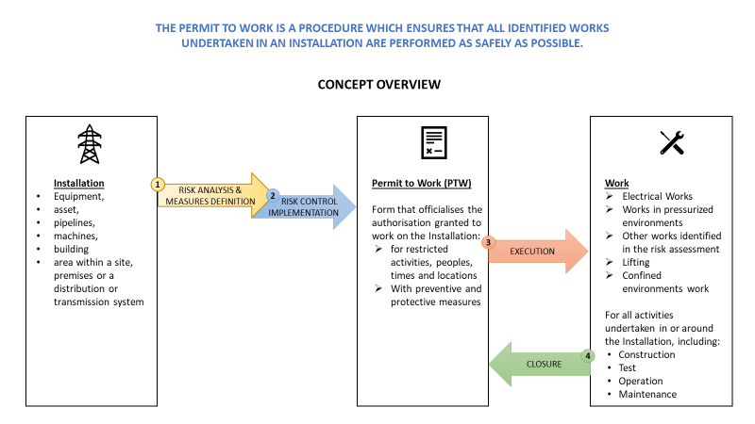
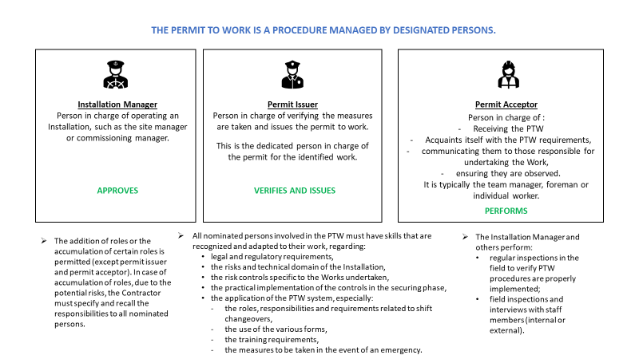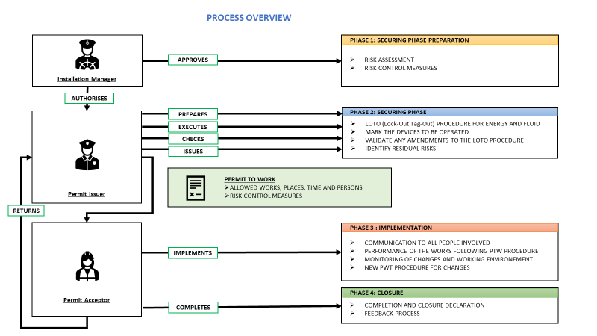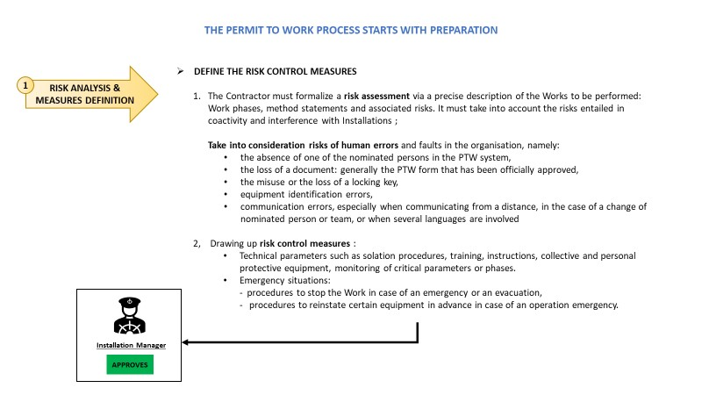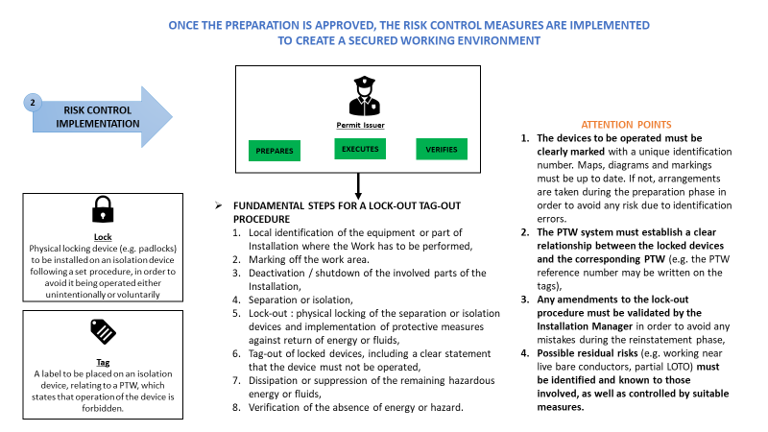

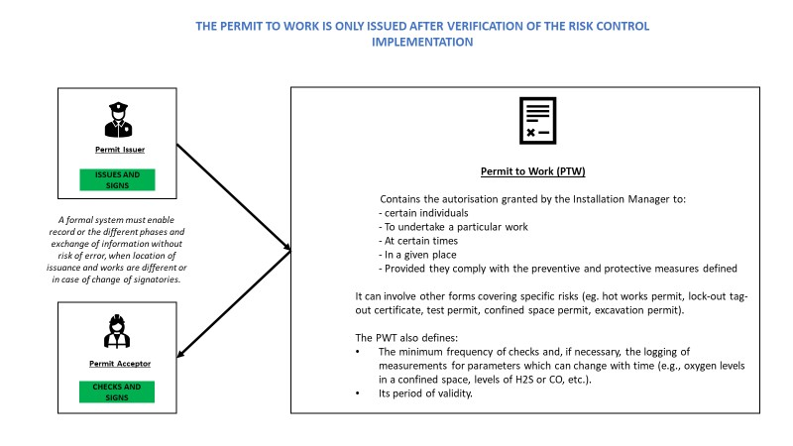

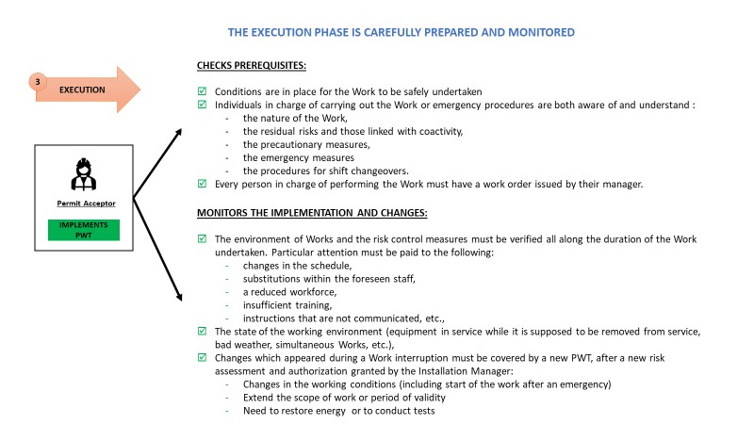

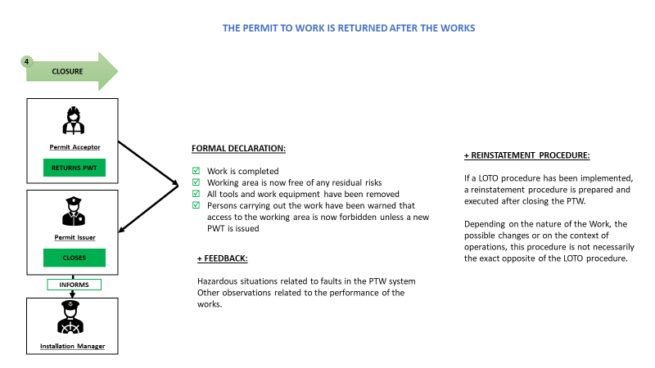

PTW GOLDEN RULES

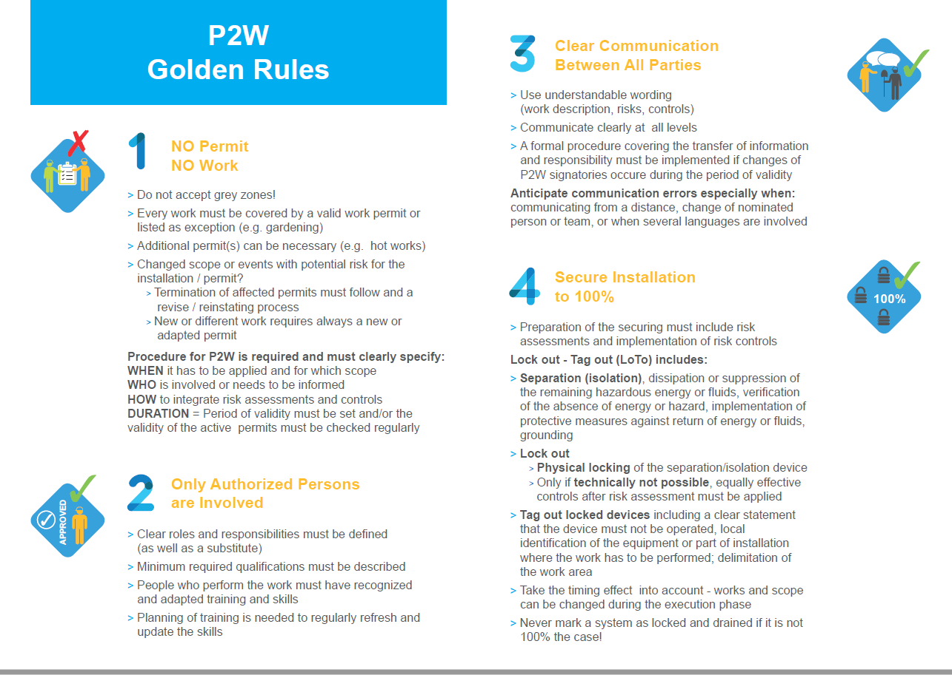
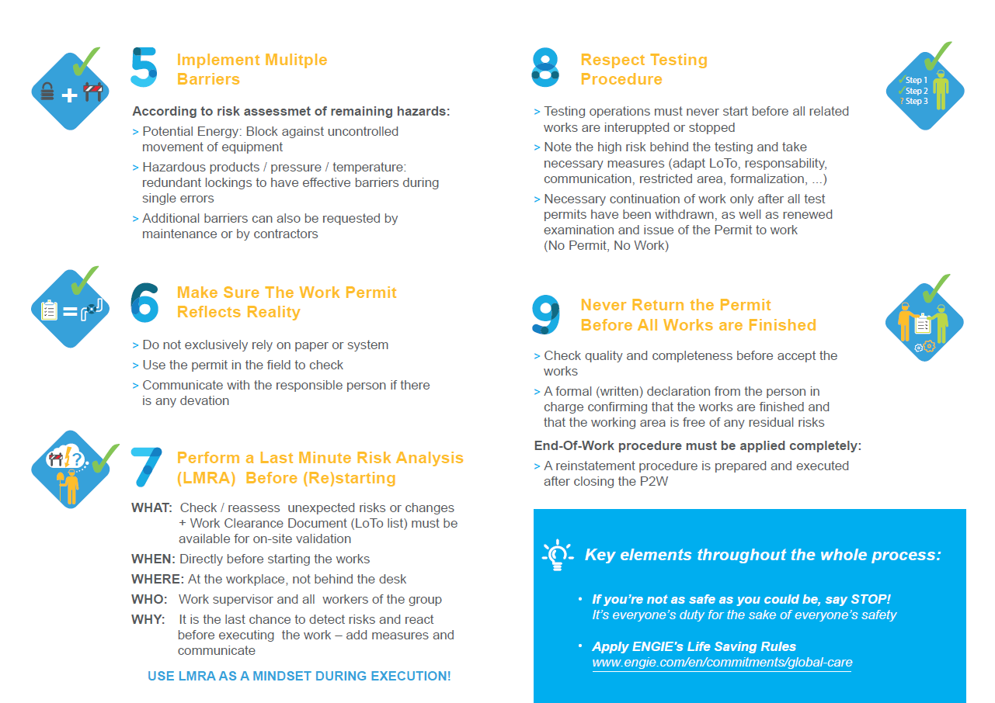

EXHIBIT 2 – LAST MINUTE RISK ASSESSMENT - LMRA
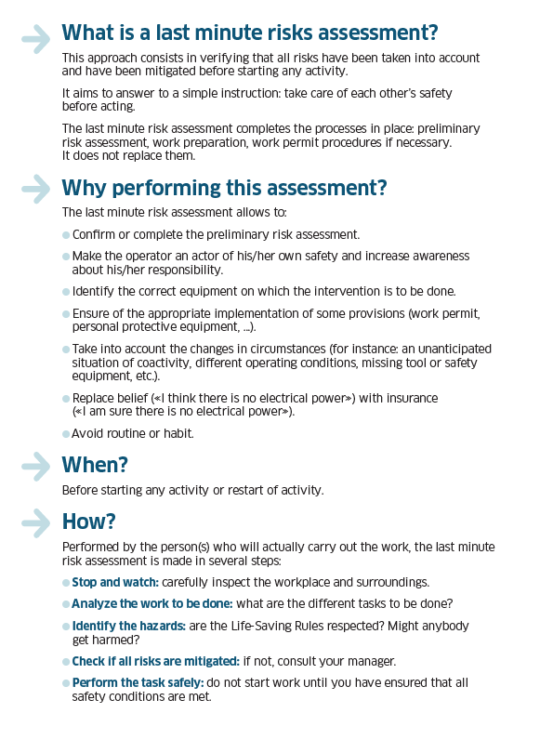
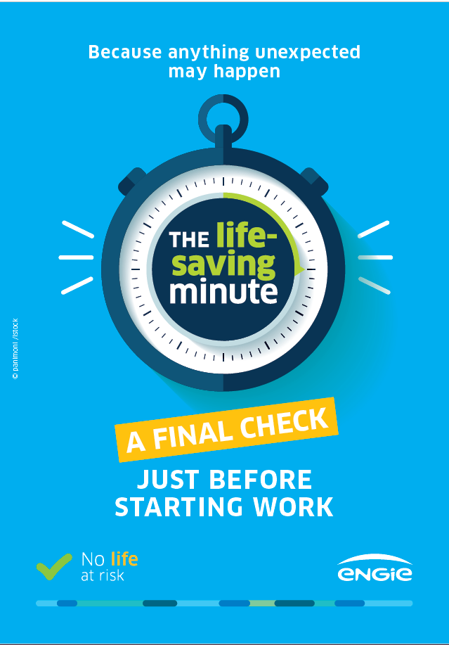
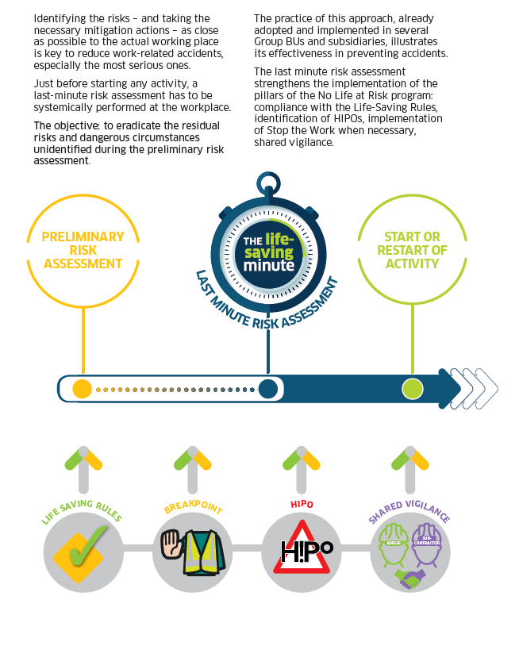

EXHIBIT 3 – “STOP THE WORK” POLICY


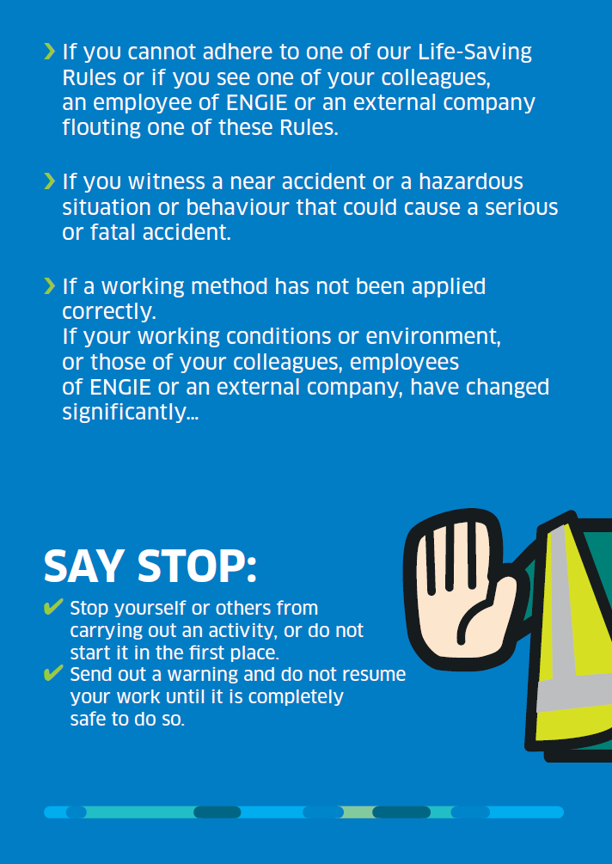

EXHIBIT 4 – KEY PERFORMANCE INDICATORS
The Contractor must report on the Lagging and Leading Key Indicators listed below as a minimum. The Contractor must identify other indicators relevant for the Project in the H&S plan and add them to this list.
The Key Indicators will be reported:
    - For everyone: Contractor’s personnel, sub-contractor’s personnel, Owner’s personnel, temporary staff, visitors at site.
    - For the period covered for the Progress Report as defined in Section 2.9 (6) as well as cumulative for the period of the Project.
LAGGING INDICATORS
Indicators of reactive nature. These are the bottom-line numbers used to evaluate the overall effectiveness of Health & Safety on the facility.
 | INDICATOR | DEFINITION | TARGET
A | Number of staff | Contractor’s and Subcontractors staff, including temporary workers. Number for the reporting period and sum for the cumulative. | N/A
B | Number of hours worked | Actual hours of work, including extra-hours | N/A
C | Number of fatal occupational accidents | Fatal accidents occurred during the execution of Works | 0
D | Number of occupational Lost Time Injury (LTI) | Occupational accidents which result in absence from work for the person injured during execution of Works, if absence equals or exceeds 1 day: work is not resumed the day (next day or next shift) after the accident | 0
E | Number of occupational accidents without lost time | Occupational accidents which do not result in absence for the person injured or absence is less than 1 day. | 0
F | Total number of days due to an occupational LTI | Cumulative numbers of lost days (off work) due to a LTI (D). | 0
G | Frequency Rate of occupational Lost Time Injury (LTIR) | C+D*1,000,000/B  = [Number of fatal occupational accidents] + [Number of occupational Lost Time ]* 1,000,000 / [Number of hours worked] | 0
H | Severity Rate of occupational accidents (SR) | F *1000/B  = [Number of occupational Lost Time * 1,000/ [Number of hours worked] | 0
I | Number of fatal commuting accidents | Fatal accidents occurred on the way to or from the Site | 0
J | Number of commuting accidents | Accidents occurred on the way to or from the Site, causing the absence of the person involved, if absence equals or exceeds 1 day | 0
K | Number of days lost due to a commuting accident | Accidents which result in absence of the person injured on the way to or from site, if absence equals or exceeds 1 day. | 0
L | Number of medically treated incidents | Events resulting in a treatment by medical nurse or doctor | 0
M | Number of first aid treatments | First aid administered either at site or in the medical facilities | 0
N | Number of breaches of LSR (Life Saving Rules) | Breach of Life Saving Rules | 0
O | Number of HiPO (High Potential Events) | Event that resulted in an incident with consequences or in a near miss and that could have led to a ​life-altering serious injury or fatality.​ | N/A
P | % of HiPO analyzed within 15 days | % of HiPO (High Potential Events) with analyze done including Root Cause Analysis and Action Plan | N/A
Q | Number of Near Miss | Event that could (have) lead to an injury | N/A
R | Number of unsafe acts and conditions reported | Deviation of safe conditions | N/A

LEADING INDICATORS
Indicators of proactive nature. These are measures to prevent and control accident
 | INDICATOR |  | DEFINITION |  | TARGET
S | Number of safety walks and safety visits performed |  | As per Section 2.8.3 Site Walkdowns |  | Min. 1 / day
T | Joint Site Safety Tour |  | As per Section 2.8.4 Joint Site Safety Tour |  | Min. 1/week
U | Number of Toolbox Talks performed |  | As per Section 2.8.1 Toolbox Talk |  | Every shift
V | Number of Joint Safety Committee meetings performed |  | As per Section 2.8.5 Joint Safety Committee Meeting |  | Min. 1 / month
W | Number of emergency drills performed |  | Test of the emergency preparedness (evacuation, fire, fall from height, medical treatment cases, …) |  | Min. 1 / month
X | Number of safety audits performed |  | Safety audits -, performed by the Contractor himself |  | At least 1 / project
Y | Number of registered H&S related training hours |  | Inductions, mentoring and other specific health and safety training |  | N/A
Z | Number of Inspection of Hazardous Equipment Checks |  | As per Section 2.3.4 Inspection of Hazardous Equipment Checks |  | Every use of equipment
AA | Number of proactive observations and actions |  | Health & Safety observations and improvement suggestions and actions |  | At least 1 / week
AB | Number of sanctions issued |  | Number of sanctions (disciplinary measure, red cards or other similar according to the Safe behavior program in Section 2.7.5 PROMOTION OF SAFE BEHAVIOR) issued. |  | NA
AC | Number of recognitions issued |  | Number of recognition action as from congratulations, public mentions, small gifts to individual or collective bonus… |  | NA

