|  |  |  |  |  |  |  |  |  |  |
| --- | --- | --- | --- | --- | --- | --- | --- | --- | --- |
| **Tihange Nuclear Power Station** | **ENGINEERING**  **SUPPORT DOCUMENT** | **Clas. Code (Ref.)** | **NT/EME/667/2013/GPGT** | | | | | | |
|  |  | **Type** | **SAP no.** | | | **Part** | | **Version** | |
|  |  | ZNO | **10010428310** | | | **000** | | **S** **01** | |
|  |  | **Date** | 25/06/2015 | | |  | | | |
| **DESCRIPTION (short title, 40 characters max):**  COMPILO: CONTRACTOR TUTORIAL | | Applicable to | | T1 | T2 | | T3 | | Site |
|  | | QA follow-up | | | | | | | NO |
|  | | Procedure to be used step-by-step | | | | | | | NA |
|  | | Procedure to be used for reference | | | | | | | NA |
|  | | Procedure for information purposes | | | | | | | NA |

|  |  |  |  |  |  |  |  |  |
| --- | --- | --- | --- | --- | --- | --- | --- | --- |
| **Long title:** | | | | | | |  | |
| **MANAGING TECHNICAL PROJECT DATA: TUTORIAL FOR CONTRACTORS** | | | | | | | Internal | |
| **Category no.:** 03.01.20 | | | | **Publisher:** BECT EME – ENG Mechanics | | | | |
| **DocMgtService:** Documents CNT Site | | | | **Original:** See DocMgtService or SAP DMS | | | | |
| **D/d:** LEBLANC/14scc | | | | **Workflow:** DEPARTMENT | | | | |
| **Doc. type code:**0413 - Support Dossier project | | | | **Business process:** 0209 – Project implementation | | | | |
| **Number of pages  (text – figures – integrated annexes)** | | |  | **Number of pages (non-integrated annexes)** | | | |  |
| **Related document(s):** | | | | | | | | |
| NA | | | |  | | | | |
|  | | | |  | | | | |
| LEBLANC P. | ART P. | JEURISSEN M. | | | VERO P. | General revision | | |
| Author(s)  **THIS DOCUMENT IS SIGNED ELECTRONICALLY** | Reviewer(s) | Verifier(s) | | | Approver(s) | Modified pages | | |

CONTENTS

1 PURPOSE 3

2 TECHNICAL DATA REQUIRED 4

2.1 types OF TECHNICAL DATA 4

2.2 SOURCE OF TECHNICAL DATA 5

2.3 RELIABILITY AND THOROUGHNESS OF THE TECHNICAL DATA PROVIDED 5

2.4 SCHEDULE AND INCLUSION OF gdtp IN THE SCHEDULE 5

3 FUNCTIONAL LOCATIONS: MAIN KEY TO SAP RESEARCH 6

4 STRUCTURE OF THE excel FILES 7

4.1 UNIQUE CHARACTER OF THE FILES 8

4.2 FILE HEADINGS: rECAP OF PROJECT DATA 8

4.3 PROTECTING CELLS AND MULTIPLE CHOICES 9

5 description OF THE FILES 10

5.1 THE ‘SERIAL NUMBERS’ FILE: t1-0 10

5.2 The ‘EQUIPMENT’ file: t5-0 12

5.3 THE ‘PREVENTIVE MAINTENANCE TASKS FILE: t3-0 15

6 key user UNIT 19

7 glossaRY 19

ANNEXE 0 : PREVIOUS versions and reasons for MODIFICATIONS 20

# PURPOSE

This tutorial is geared towards contractors and aims to accurately outline Electrabel Tihange’s expectations regarding the technical data to be provided by contractors (S-T) throughout the a project, whether said data cover:

* the modification of an existing facility;
* a new project.

There are two types of technical data collected by contractors and passed on to Electrabel (EBL):

* Technical data regarding equipment assembled and placed on the site in connection with the project.
* Maintenance tasks required by manufacturers for said equipment.

You will be required to provide this data in three Excel files, which will be sent to you once the project begins.

This procedure is part of an overall process aiming to collect all technical data on a project from all involved (e.g. engineering firms, in-house EBL departments) at various stages over the course of the project.

The process governing this Technical Project Data Management (GDTP) procedure has been named **CompilO** and dovetails with a general approach to improving the reliability of facilities.

All technical data received by EBL will be checked on site by the CompilO team before being encrypted into SAP.

Please note that it is extremely important that the technical data you send to EBL are reliable and thorough.

# TECHNICAL DATA REQUIRED

## types OF TECHNICAL DATA

As mentioned in section 1, there are two types of data to be provided by contractors:

* Data on equipment.
* Preventive maintenance tasks for all equipment.

### Data on equipment

The term ‘equipment’ covers mechanical, electrical or I&C components provided by you in connection with the project for which you have been contacted.

These technical data are specific to each component and accurately outline said components’ characteristics.

The following is provided for a valve, for instance:

* Serial number (in a separate file: **T1-0**).
* Brand.
* Type/model.
* Type of value.
* Diameter and rating.
* Material of the body of the valve. in file **T5-0**
* Engine type (associated with the actuator).
* Fluid created by the valve.
* How it is connected to the pipes.

### Preventive maintenance tasks

Using the Excel file (**T4-0**) emailed to you, this is a summary of the maintenance tasks recommended by manufacturers.

You are not required to conduct a MERIDE, AMDEC or RCM study; rather, you are expected to list (in the xlsx file) all level 1 maintenance tasks required by manufacturers, without questioning them.

Most of these tasks will involve, for example:

* lubrication;
* 360º checks;
* systematic replacements.

These maintenance tasks are generally listed in the functional memos or user manuals provided by manufacturers.

It is worth noting that said functional memos must be included in the technical file sent to us for the commissioning.

## SOURCE OF TECHNICAL DATA

The technical data to be provided regarding the equipment and maintenance tasks recommended by manufacturers have a range of sources:

* Primarily the manufacturer’s technical documentation that makes up the technical file to be provided to EBL as part of the manufacturer file.
* Schematic diagrams, flow diagrams, isometrics and your own plans with Certified For Construction (CFC) status.
* Data from nameplates on equipment to be installed by you on the site as part of the project for which you were contacted.

In accordance with best practices regarding document management and quality assurance, you are highly advised to compile the technical file from the start of the project and to fill it in over the course of the project, rather than (as is often the case) leaving this task to the last minute and rushing it.

## RELIABILITY AND THOROUGHNESS OF THE TECHNICAL DATA PROVIDED

The technical data collected in the three Excel files received by the **CompilO** unit must be thorough and reliable.

Once the CompilO unit has received the xlsx files completed by you, the unit will carry out several checks on-site to verify that the data received corresponds with the equipment in place.

Following these checks, any discrepancies noted between the technical data in the xlsx files and the reality on the ground will result in the incorrect files being returned to the sender for correction until pertinent and reliable data are provided.

Once corrected, the technical data in the xlsx files will again undergo a joint control on site.

Please note that you may be required to assume any charges generated by additional checks triggered by any errors found. This will be decided by the Implementation Manager (ReR) authorised by EBL, the EBL Project Manager (CDP) or the Tractebel contract owner (TM-TE).

## SCHEDULE AND INCLUSION OF gdtp IN THE SCHEDULE

The three xlsx files will be emailed to you as soon as possible, usually several weeks before the project is launched at the Tihange nuclear power station (CNT) site, so that you can familiarise yourself with the format and best organise your team to complete this task.

The emails will indicate a theoretical deadline on which you will be expected to return the duly completed files to us.

This theoretical deadline could be changed at your request depending on the project’s progress on site.

The aim is clearly to obtain all required technical information as quickly as possible with a view to encrypting them in the SAP database once they have been checked.

The law requires all technical project data to be encrypted for commissioning (MSI).

# FUNCTIONAL LOCATIONS: MAIN KEY TO SAP RESEARCH

Functional locations (PTs) are used on flow and wiring diagrams and indicate the location of the equipment.

To illustrate, the equipment is like a car and the PT is the parking spot in which it is parked.

PTs always have the same structure:

PCT 2 - EDN - V 474

Block/unit Amount of increase

Circuit three-digit code

Type of equipment

The unit/block number and circuit are listed in the title block in your CFC diagrams and plans used for the site kick-off.

The document number and revision number are also included in the title block:

Document number

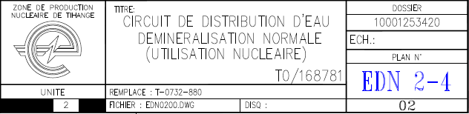

Block Circuit

Revision number

The type of equipment and its number are provided at the right place on the diagram itself.

Valve no. 856

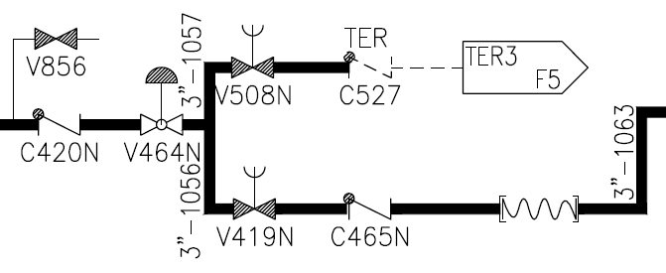

Clasp no. 465N

As such:

* The PT is unique.
* A single component (or piece of equipment) can be positioned in several separate PTs.
* The technical data and associated preventive maintenance tasks are identical for an individual component (or piece of equipment).
* Several PTs could have the same technical data and associated maintenance tasks.

As explained above, PTs are therefore the main key to carrying out searches in SAP.

The PTs as well as their name are already provided in the xlsx files sent to you and cannot be changed.

The PTs listed in the files sent to you correspond to the scope of your project and thus the components you will use.

# STRUCTURE OF THE excel FILES

CompilO also strives to standardise and harmonise the format of the files exchanged between you as a contractor, and EBL.

As the CompilO process is relatively complex, GDTP has been digitised so as to make it possible to encrypt technical project data in an organised and controlled manner.

As such, the files that you will receive are created and then processed by a software developed by EBL expressly for this purpose.

To guarantee that the entire process runs smoothly, it is vital that you respect the rules outlined in this section.

## UNIQUE CHARACTER OF THE FILES

The xlsx files that you receive as part of GDTP are created automatically by a software developed specifically to encrypt technical data into SAP.

As such, every file generated by the software is unique and specific to the scope of the project assigned to you. It includes a TAG, a unique number created automatically by an algorithm within the same software.

Once the relevance of the technical data in the files you send to us has been checked and approved, these data will be ‘assimilated’ by the software for processing with a view to being encrypted into SAP by the authorised EBL department.

Owing to the TAG, the software only recognises and accepts files generated by the software itself.

To ensure that the entire process runs smoothly, it is therefore imperative and mandatory that you return to us the **original file duly completed**.

The original file can be renamed and processed using all available versions of Microsoft Office (from 93-97 to 2014).

You can also make copies of the file so long as the final file you return to us is the original file you received via email from CompilO.

## FILE HEADINGS: rECAP OF PROJECT DATA

Every Excel file you receive will have a heading providing information specific to the project you have been assigned by EBL.

This information is worded as follows:

Project: 0848-Best Couche 1 🡪 EBL project number - Description

Modification number: DM E1/14 /08 🡪 EBL modification file number

Contract: M01-Civil engineering 🡪 EBL contract number - Description

Batch: L01a-anti-flood wall 🡪 EBL batch number - Description

Contractor: FRANKY 🡪 Name of the company in charge of the batch

Request no.: 99000678546

Order no.: 5500007654 🡪 Refers to the order passed on to the contractor

Location: 10

*Please note: the information provided in the example above are fictitious.*

This information should help you to link the xlsx file on which you are working to the relevant project at any time.

## PROTECTING CELLS AND MULTIPLE CHOICES

As explained above, the xlsx files sent and received are processed by software. As such, these files must have a standardised format to ensure that the data exchanged can be processed.

You are therefore unable to modify the structure of these files, meaning that you cannot:

* add or delete columns;
* change, delete or write in the ‘Number – Functional Location – Name’ columns;
* change, delete or write in the heading;
* use the sort function;
* change the case or appearance of the cells.

Any attempt to modify the structure or write in protected cells will cause the following message to appear in a dialogue box:

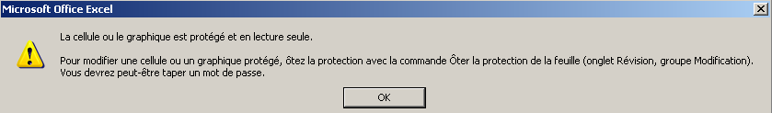

Similarly, the only authorised answer in most of the cells are one of those suggested in the drop-down menus.

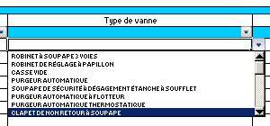

Cell created by the drop-down menu.

By selecting this cell, an arrow appears indicating the drop-down menu.

You need to choose from the options available.

If none of the options offered in the drop-down menu apply to you, contact the **CompilO** unit to discuss how to proceed.

The content and form of the files sent to you will be regularly modified in line with your comments, notes and suggestions.

Please do not hesitate to send us your comments and suggestions; we will incorporate them as much as possible within the limits of the software’s operation and in line with the rules set by EBL.

# description OF THE FILES

The examples provided below are fictitious and do not relate to any actual projects.

## THE ‘SERIAL NUMBERS’ FILE: t1-0

One piece of information we require from you is the serial number of the equipment on site. This number (which is usually located on the equipment’s nameplate) is unique and specific to the equipment installed.

Depending on the situation, it is not always necessary to provide this number. It is only mandatory to provide the number and list it in the xlsx file for the following types of equipment:

* All classified equipment.
* Engines.
* Valves with a diameter > 2 inches.
* Pumps.

As regards other types of equipment, contact the **CompilO** unit (section 6) for confirmation of whether you need to provide the serial numbers.

The file used to encrypt the serial numbers is called:

EBL-CNT-GD-FORM-M001-L001-T1-0-OUT.XLS

Standard ID of the serial number file

Project ID

Fictitious example of a completed T1-0 file:

Non-modifiable heading indicating the project information.

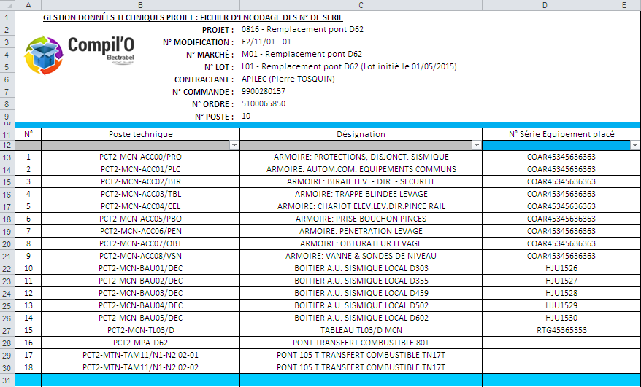

Non-modifiable PT data and name

List of serial numbers to be completed by you based on the equipment on site

## The ‘EQUIPMENT’ file: t5-0

We use this file to compile technical data on the equipment you will need to bring on site in connection with the project assigned by EBL.

Once processed by the software, these data will serve as a basis for creating types of construction, Bills Of Material and the articles encrypted in SAP by EBL.

The data provided must make it possible to create a clear order for a part.

These data must therefore be reliable (As Built) and thorough.

We will pay a great deal of attention to the completed file sent to us by you, and we will check it on site to guarantee the relevance of the data provided.

To recap: as stipulated in section 2.3, any discrepancies between the data in the file and that noted on site will be rechecked and returned to you for you to correct the noted errors.

You may be billed for this rework, depending on the decision of the EBL Project Manager or TM-TE.

The file intended to summarise the technical data on the equipment is called:

EBL-CNT-GD-FORM-M001-L001- T5-0-OUT.XLS

Standard ID of the equipment file

Project ID

The protection granted to this file (see section 4.3) authorises the following actions:

* Automatic filter.
* Copy and paste.

Please remember that you must return the original file duly completed so that it can be incorporated and processed by the software.

However, you can rename it.

These prerequisites are outlined in section 4.1.

In the case of doubt or misunderstandings, please contact the **CompilO** unit, who will be able to help you (see section 6).

Once opened, the file contains several tabs at the bottoms of the sheet:

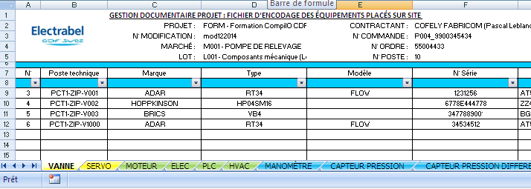

Each tab corresponds to a group of equipment.

The Functional Location column lists the PT, i.e. the site at which the various pieces of equipment belonging to the same group are found.

The group of equipment determines the technical data required in each tab.

In each tab, you only need to fill in those rows in which a PT number is indicated. These PTs correspond to the scope of your project.

The tabs available corresponding to groups of equipment are as follows:

* VALVE: valves, clasps.
* SERVO: servomotor, electrical-pneumatic-hydraulic actuator.
* MOTOR: electric engine.
* **ELEC**: electric and control equipment different to those listed in a tab.
* PLC: Automations and associated equipment (e.g. card slot).
* **HVAC**: HVAC equipment different to those listed in a tab.
* MANO: Bourdon pressure gauge.
* PRESSURE SENSOR: pressure sensor.
* DIFFERENTIAL PRESSURE SENSOR: differential pressure sensor.
* INDICATOR: digital indicator.
* T SENSOR: temperature sensor.
* FLOW METER: flow meter.
* SUPPLY: electricity supply.
* RECORDER: recorder.
* PRESSURE SWITCH: pressure switch.
* THERMOSTAT: thermostat.
* ANALYSER: analyser.
* CONVERTER: converter.
* LEVEL SENSOR: level sensor.
* PUMP: pump.
* VENTILATOR: ventilator.
* FILTER: filter.
* RESERVOIR: reservoir, can, tank, feeder tank.
* COMPRESSOR: compressor.
* **OTHER MEC**: mechanical equipment different to those listed in a tab.

This list is not exhaustive and will be added to regularly. These changes will result in an update of the files, software and this memo.

The tabs indicated in bold in the above list make it possible to encrypt the technical data of equipment not yet included in a specific tab.

These specific tabs (which we could call ‘general’ tabs) comprise the usual fields, such as:

* brand;
* type;
* model;
* manufacturer plan number.

A ‘Description’ field is provided with a view to accurately defining additional technical data.

This free text field allows you to encrypt the technical data of the corresponding item of equipment. These data must be sufficiently accurate to result in a clear order of a part.

As for these general tabs, the file enables you to wrap the text in a cell (Alt + Enter) to give the text a clear and understandable structure.

To view the text edited in this way, you can increase the size of the viewing pane as shown below:

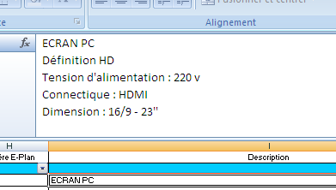

Position your mouse here and drag it downwards – the viewing pane for the text in the cell will appear.

Write in the cell or the viewing pane by using Alt+Enter to move on to the following row.

## THE ‘PREVENTIVE MAINTENANCE TASKS FILE: t3-0

As its name suggests, this file aims to consolidate and summarise all maintenance tasks recommended by manufacturers.

It is a comprehensive report of suggested preventive maintenance tasks recommended by manufacturers, without questioning the regularity, designation of tasks or any other information.

The file intended to record the maintenance tasks is called:

EBL-CNT-GD-FORM-M001-L001- T3-0-OUT.XLS

Standard Maintenance file ID

Project ID

Once you have opened the file, each row corresponds to a PT or a set of PTs.

One or more maintenance tasks can be assigned to every PT or set of PTs (corresponding to one or more ‘locations’ at which a specific piece of equipment is located).

This file’s protection (see section 4.3) authorises the following actions:

* automatic filter;
* copy and paste;
* insert rows.

Please remember that you must return to us the original file duly completed so that it can be assimilated and processed by the software.

However, you are authorised to rename it.

These prerequisites are outlined in section 4.1.

Section 5.3.1. shows the file received based on a fictitious example, while section 5.3.2. shows the same file filled in by the contractor.

### ‘MAINTENANCE TASKS FILE RECEIVED BY THE CONTRACTOR

Non-modifiable heading listing the project and contractor information Titles and names in non-modifiable columns

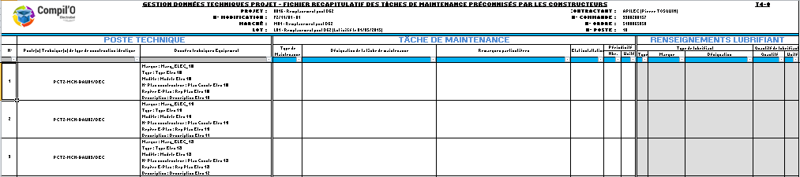

Non-modifiable PT data

**Text field**:

Description of the maintenance activity

Non-modifiable technical data about the type of equipment

To be filled in if **LUB** activity

The field turns grey if the activity type selected is LUB

**Type of lubricant** (drop-down menu)

H: oil

G: grease

**Lubricant brand** (text field)

**Name** (text field)

Standard name of the lubricant (e.g. EP3)

**Quantity** (text field)

Enter a number depending on the unit chosen

**Unit** (drop-down menu)

L: litre

Gr: gram

Cm³: centimetres cubed

**Text field**:

Any special comments

**Drop-down menu: type of activity**

LUB: lubrication (e.g. greasing, draining, extra lubrication)

NET: cleaning

REE: systematic replacement (systematic regular replacements)

CTV: visual check (360º check does not required any dismantling)

CTI: internal check (required dismantling, opening)

TST: tests, trials (functional test)

MES: measurement (e.g. vibration, oil analysis, thermography)

DIV: other

**Drop-down menu: status of the facility**

In operation: if the maintenance activity can be carried out in line with the health and safety rules, with the facility at normal operation

Shut down: need to shut down the facility to carry out the maintenance activity

**Regularity of maintenance tasks**

The regularity comprises a number (**text field**) and the unit of time (**drop-down menu**)

Unit drop-down menu:

H: hour

J: day

M: month

A: year

R: overhaul or unit shutdown

### Example of a file filled in by contractors

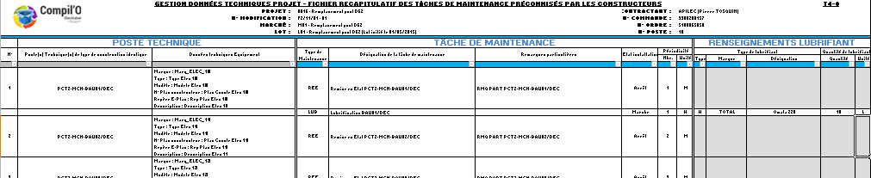

Maintenance activity **LUB** has been selected:

The cells used to encrypt lubrication information are coloured grey and must be filled in

The PT covers one piece of equipment for which the manufacturer recommended several maintenance tasks:

All you need to do now is insert one row below the original one. To do this:

Select the line below the space where you would like to insert an empty row

Right click on your mouse

Select ‘Insert’

Repeat process as often as required

**Notes**

If the PT or PTs cover equipment for which the manufacturer(s) do not recommend any specific maintenance task:

* Columns D to N remain empty.
* The ‘Special comments’ column may indicate ‘NO MAINTENANCE’.

If a PT is removed as part of the project:

It is clear that, for the equipment number indicated in connection with the project, no maintenance task is possible.

As such, the row remains empty.

# key user UNIT

If you encounter any problems or have any concerns regarding technical data or maintenance tasks while compiling the various technical data, do not hesitate to contact the **CompilO** unit by email at:

**cnt-compilo@electrabel.com**

**CompilO** will process your request as quickly as possible and will contact you with a response.

You also need to send the duly completed files to this address.

# glossaRY

BOM 🡪 Bill of Material

CFC 🡪 Certified For Construction

CDP 🡪 Project Manager

CNT 🡪 Tihange nuclear power station

CompilO 🡪 Software and process for managing technical data

EBL 🡪 Electrabel

GDTP 🡪 Management of technical project data

HVAC 🡪 Heating, ventilation and air conditioning

I&C 🡪 Instrumentation and control

MSI 🡪 Commissioning

ReR 🡪 Implementation Manager

RP 🡪 Provisional acceptance

S-T 🡪 Contractor

PT 🡪 Functional Location

TM-TE 🡪 Tractebel contract owner

TE 🡪 Tractebel Engineering

Xlsx 🡪 Excel file

PREVIOUS versions and reasons for MODIFICATIONS

|  |  |  |
| --- | --- | --- |
| Version | Date | Reason |
| S 00 | 26/06/2015 | Creation of memo. |
| S 01 | Current version | Update following changes to the CompilO process. |

**DISSEMINATION FRAMEWORK – CATEGORIES (version 01-2015)**

|  |  |  |  |  |  |  |  |  |  |  |  |  |  |  |  |  |
| --- | --- | --- | --- | --- | --- | --- | --- | --- | --- | --- | --- | --- | --- | --- | --- | --- |
|  |  | | | | | | |  |  | | | | | | | |
| **OWNERS AND CONTROLS** | | **SIMU** | **DCE** | **S** | **T1** | **T2** | **T3** |  | **OTHER CATEGORIES** | | **SIMU** | **DCE** | **S** | **T1** | **T2** | **T3** |
| **OPR** | Main control room |  |  |  |  |  |  | Security archives | |  |  |  |  |  |  |
| BUS control room/shutdown panel |  |  |  |  |  |  | **CARE** | CARE SRP Logis.: decontamination room (via TA SRP) |  |  |  |  |  |  |
| TEL control room |  |  |  |  |  |  |
| TEG control room |  |  |  |  |  |  | CARE SRP Logis.: CHRH / CHU hospitals (via TA SRP) |  |  |  |  |  |  |
| TDS control room |  |  |  |  |  |  |
| Unit Operating Centre UOC |  |  |  |  |  |  | CARE SRP: EPI – outside zone (via TA SRP) |  |  |  |  |  |  |
| via CARE NS  via OPR |
| Site Operating Centre SOC |  |  |  |  |  |  | CARE SRP: CARA / VRP (via TA SRP) |  |  |  |  |  |  |
| via CARE NS  via Filings |
| OPS Support Tests |  |  |  |  |  |  | CARE SRP: equipment output  (via TA SRP) |  |  |  |  |  |  |
| OPC Chemistry |  |  |  |  |  |  |
| OPC Chemistry Lab HZ |  |  |  |  |  |  | CARE PPA (access) |  |  |  |  |  |  |
| OPC Chemistry Lab Z |  |  |  |  |  |  |
| OPD Waste (foreman room) |  |  |  |  |  |  | CARE SRP Methods (Site) |  |  |  |  |  |  |
| Main SIMU control room (SFS) |  |  |  |  |  |  |
| Secondary SIMU control room (SMF) |  |  |  |  |  |  | **OPR** | DE building (deactivation pool) |  |  |  |  |  |  |
| Classroom (Fermi) |  |  |  |  |  |  |
| Instructor station |  |  |  |  |  |  | **PPM** | PPM/QA |  |  |  |  |  |  |
| Central OPR (trainers) AR22 |  |  |  |  |  |  |
| **FUEL** | FUEL (local archives) |  |  |  |  |  |  | **LTO** | LTO (secretary) |  |  |  |  |  |  |
| FUEL (pool) |  |  |  |  |  |  |
| **MNT** | Archive/scheduling |  |  |  |  |  |  | **ENG** | ENG (secretary) |  |  |  |  |  |  |
| **CARE** | CARE SRP Logis.: class. ref. - (via TA SRP) |  |  |  |  |  |  |
| CARE SRP Interv.: class. ref. HZ - (via TA SRP) |  |  |  |  |  |  | **MNT** | Electricity/Instrumentation (calculators) |  |  |  |  |  |  |
| CARE SRP Interv.: RP Z room - (via TA SRP) |  |  |  |  |  |  |

**ELECTRONIC DISSEMINATION (SAP DMS)**

|  |  |  |  |  |  |  |
| --- | --- | --- | --- | --- | --- | --- |
| **SBWP** |  | **T1** | | **T2** | | **T3** |
|  |  | |  | |  |
| **NAME/OUTLOOK LIST LIOUTLOOK** | LEBLANC P. | | DE RUETTE M. | | CNT - ENGINEERING Service ELI | |
| HOLLEVOET J. | | BELLIN G. | | CNT - ENGINEERING Service EME | |
| WILMART J.-P. | | SWERTS D. | | CNT - ENGINEERING Service EPM | |
| SZEDLESKI D. | | HOUART S. | | CNT - ENGINEERING Service ESP | |
| HOFKENS W. | | HELLAS F. | | CNT - ENGINEERING Service ESH | |
| CHARTIER S. | | DEFAWE A. | |  | |
| MOREAU P. | | LAMBRECHTS P. | |  | |
| LOUSBERG A. | | COLINET P. | |  | |
| VERO P. | | CUDLICI C. | |  | |

**ADDITIONAL ELECTRONIC DISSEMINATION (OUTLOOK/PORTAL)**

|  |  |  |  |  |  |
| --- | --- | --- | --- | --- | --- |
|  | **Mail+ PDF** | **Portal** |  | **Mail+ PDF** | **Portal** |
| DocMgt Nuclear TE (TRACTEBEL ENGINEERING – BELGIUM) |  |  | AIA: [rlahaye@vincotte.be](mailto:rlahaye@vincotte.be) |  |  |
| Tractebel portal (DM) |  |  | AIB VINCOTTE: |  |  |
| BEL V: [spoc_ti1@belv.be](mailto:spoc_ti1@belv.be) |  |  | SPIE BELGIUM: [stephanie.bauduin@spie.com](mailto:stephanie.bauduin@spie.com) |  |  |
| BEL V: [spoc_ti2@belv.be](mailto:spoc_ti2@belv.be) |  |  | COFELY FABRICOM INDUSTRIE SUD SA: [marc.haentjens@cofelyfabricom-gdfsuez.com](mailto:marc.haentjens@cofelyfabricom-gdfsuez.com) |  |  |
| BEL V: [spoc_ti3@belv.be](mailto:spoc_ti3@belv.be) |  |  |
| BEL V: [spoc_tis@belv.be](mailto:spoc_tis@belv.be) |  |  | STORK: [alain.sougne@stork.com](mailto:alain.sougne@stork.com) |  |  |
| AFCN : [christian.vandecasteele@fanc.fgov.be](mailto:christian.vandecasteele@fanc.fgov.be) |  |  | CMI: [corine.lemoine@cmigroupe.com](mailto:corine.lemoine@cmigroupe.com) |  |  |
| ATTENTIA Tihange (Electrabel) |  |  |  |  |  |
|  |  |  |  |  |  |

***Key****:* ***X*** *= email (SAP or OUTLOOK) or availability on portal /* ***n*** *= number of paper copies (only for categories)*